# Part 2: Testing, Debugging, and Correction

## Test Plan & Documentation

A structured test plan was created to systematically test the Razeus Games website. The plan covered all key features including navigation, forms, responsiveness, and interactive elements. Each feature was tested using multiple test cases with expected outcomes, actual results, and status documented.

### Test Cases:

|  |  |  |  |  |  |
| --- | --- | --- | --- | --- | --- |
| **ID** | **Feature** | **Test Case** | **Expected Result** | **Actual Result** | **Status** |
| 1 | Navigation | Hover on links | Highlights and hover animation | Highlights and hover animation | Pass |
| 2 | Navigation | Click on Home link | Redirect to Home page, Home link highlighted | Redirected and highlighted correctly | Pass |
| 3 | Navigation | Click on About Us link | Redirect to About Us page, previous link unhighlighted, About Us highlighted | Redirected and highlighted correctly | Pass |
| 4 | Navigation Dropdown | Click on dropdown link | Opens dropdown menu, links visible with hover effect | Dropdown menu opened, hover effect working | Pass |
| 5 | Navigation Button | Click on Register button | Redirects to register page, hover animation works | Redirected to register page, hover animation works | Pass |
| 6 | Form Validation | Submit blank form | Form not submitted, error messages displayed | Form didn’t submit, error messages shown | Pass |
| 7 | Form Validation | Enter username <5 chars | Error message: “The username must have at least 5 characters” | Error message displayed | Pass |
| 8 | Form Validation | Enter username ≥5 chars | Success message: “Username is valid” | Success message displayed | Pass |
| 9 | Form Validation | Enter invalid email | Error message: “Please enter a valid email address” | Error message displayed | Pass |
| 10 | Form Validation | Enter valid email | Success message: “Email is valid” | Success message displayed | Pass |
| 11 | Form Validation | Enter age <1 or >100 | Error message: “Please enter an age between 1 and 100” | Error message displayed | Pass |
| 12 | Form Validation | Enter age 1–100 | Success message: “Age is valid” | Success message displayed | Pass |
| 13 | Form Validation | Enter future date of birth | Error message: “Your date of birth can't be in the future” | Error message displayed | Pass |
| 14 | Form Validation | DOB doesn’t match age | Error message: “Your date of birth does not match your age” | Error message displayed | Pass |
| 15 | Form Validation | DOB matches age | Success message: “Date of birth matches your age” | Success message displayed | Pass |
| 16 | Cart | Click “Add to Cart” on an item | Item added to cart, badge increments | Item added, badge incremented | Pass |
| 17 | Cart | Add same item twice | Alert: “This item is already in the cart” | Alert shown, duplicate not added | Pass |
| 18 | Cart | Increment/decrement quantity | Quantity changes correctly, total updates | Quantity updated, total updated | Pass |
| 19 | Cart | Remove item from cart | Item removed, total updated, badge decrements | Item removed, total updated, badge decremented | Pass |
| 20 | Checkout | Click “Checkout” with empty cart | Alert: “Your cart is empty” | Alert displayed | Pass |
| 21 | Checkout | Click “Checkout” with items | Cart cleared, total reset, badge reset, success alert | Cart cleared, alert displayed, badge reset | Pass |
| 22 | Responsiveness | Desktop view | Layout displays correctly | Layout correct | Pass |
| 23 | Responsiveness | Tablet view | Layout adjusts, no overlap | Layout correct | Pass |
| 24 | Responsiveness | Mobile view | Layout adjusts, navigation works | Layout correct | Pass |
| 25 | Cross-browser | Chrome | All features work | Works as expected | Pass |
| 26 | Cross-browser | Firefox | All features work | Works as expected | Pass |
| 27 | Cross-browser | Edge | All features work | Works as expected | Pass |

## Testing Evidence

Screenshot ID 1:



Screenshot ID 2:



Screenshot ID 3:



Screenshot ID 4:



Screenshot ID 5:

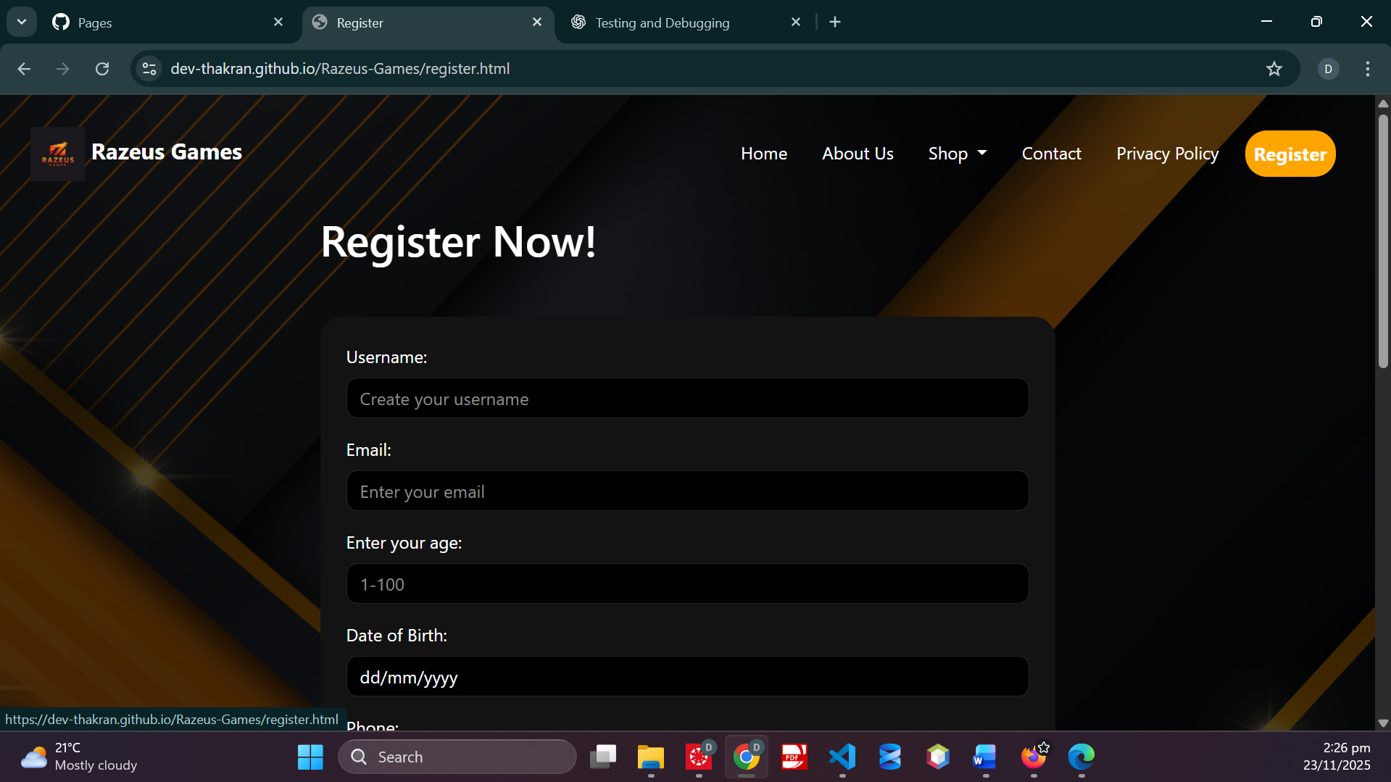

Screenshot ID 6:

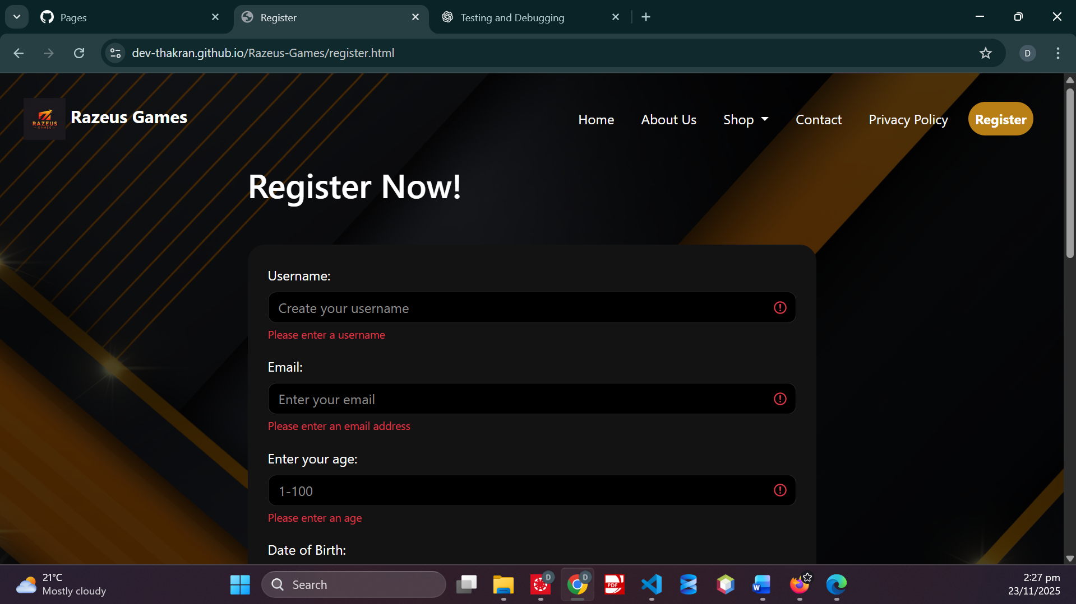

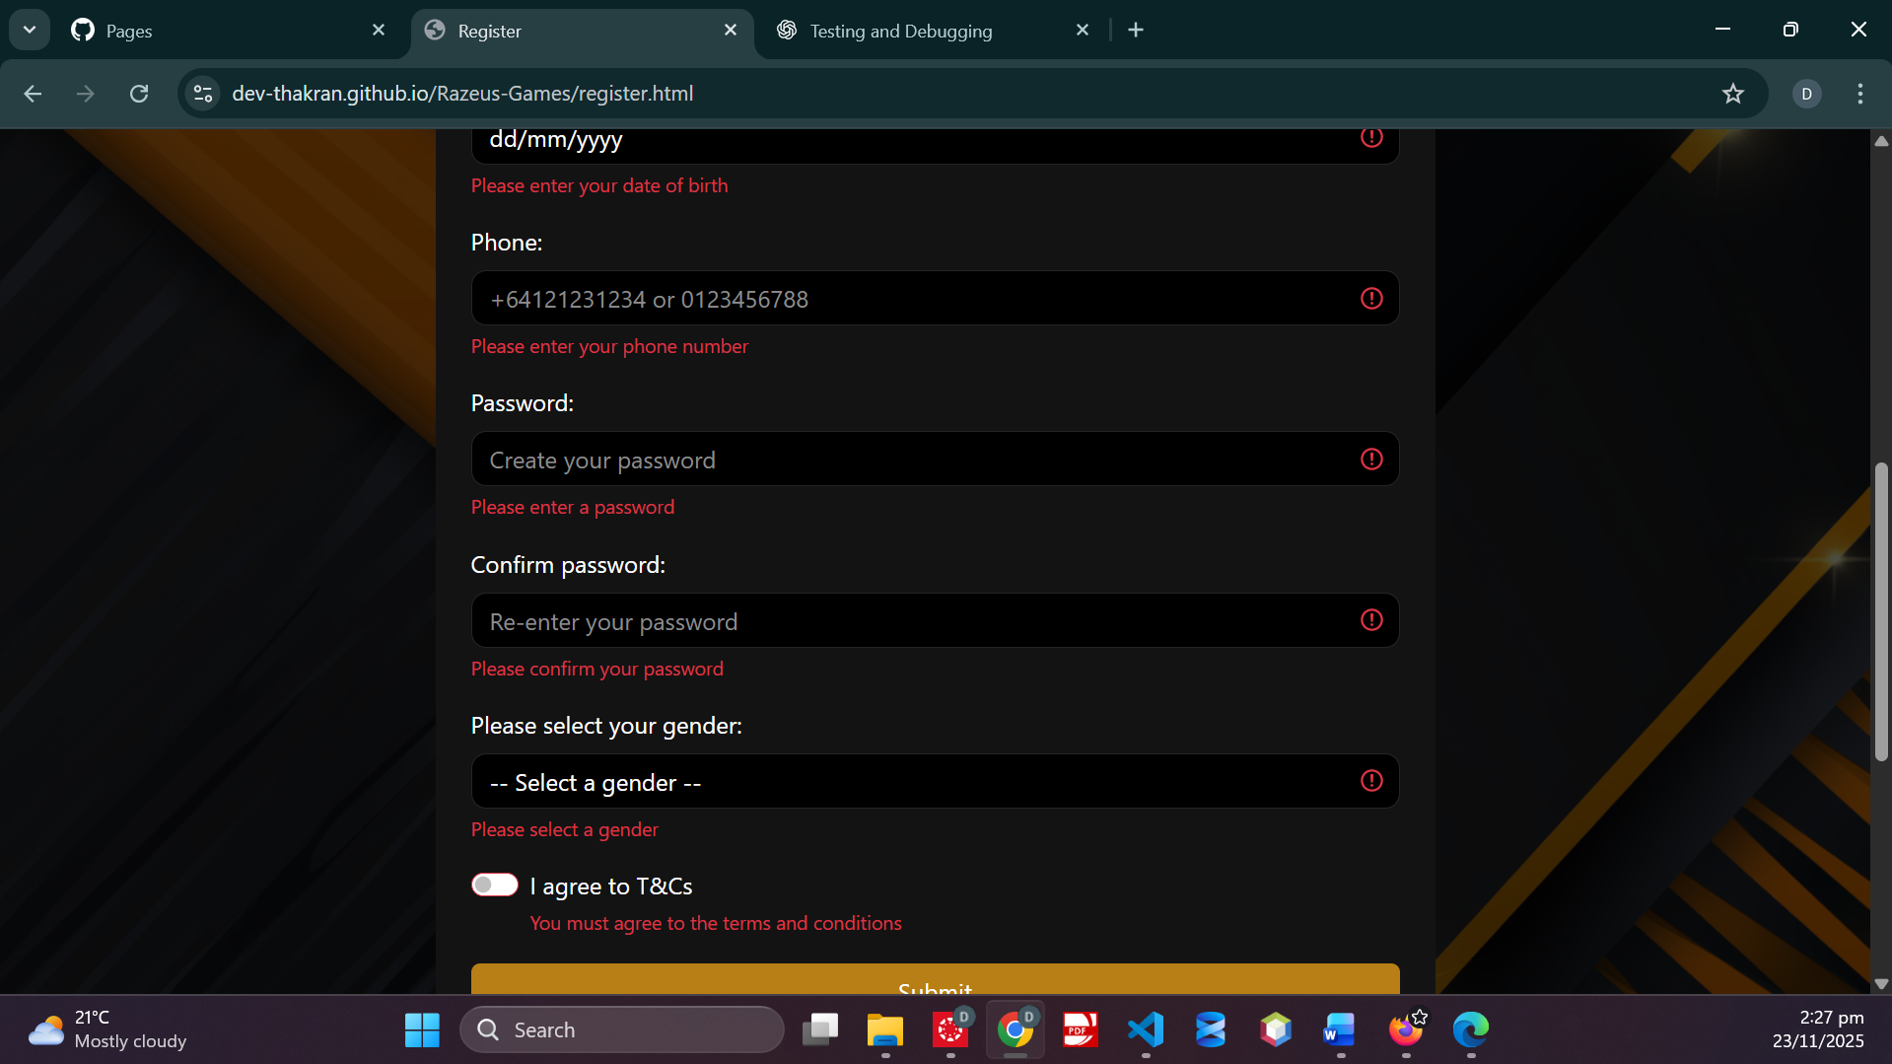

Screenshot ID 7:

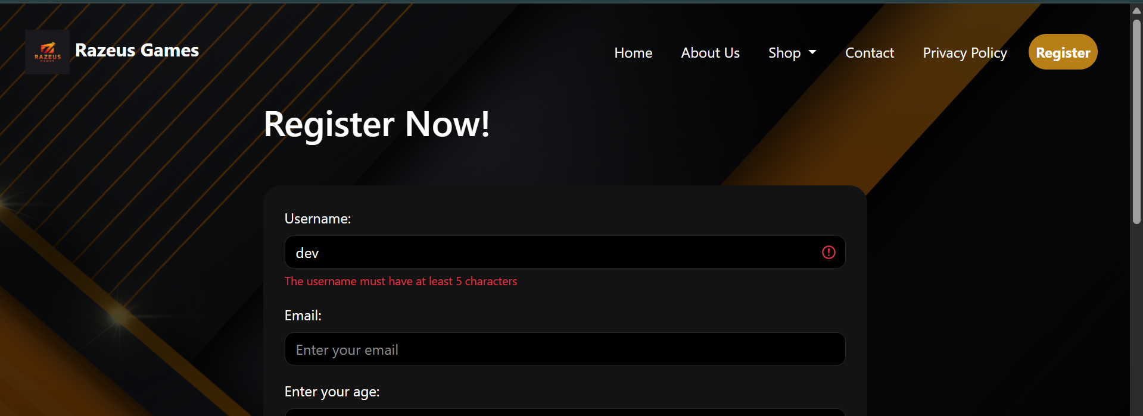

Screenshot ID 8:



Screenshot ID 9:

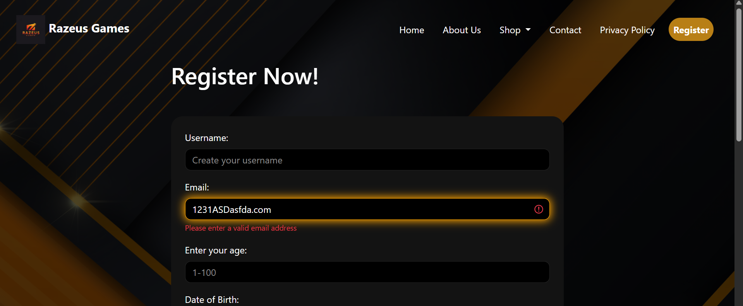

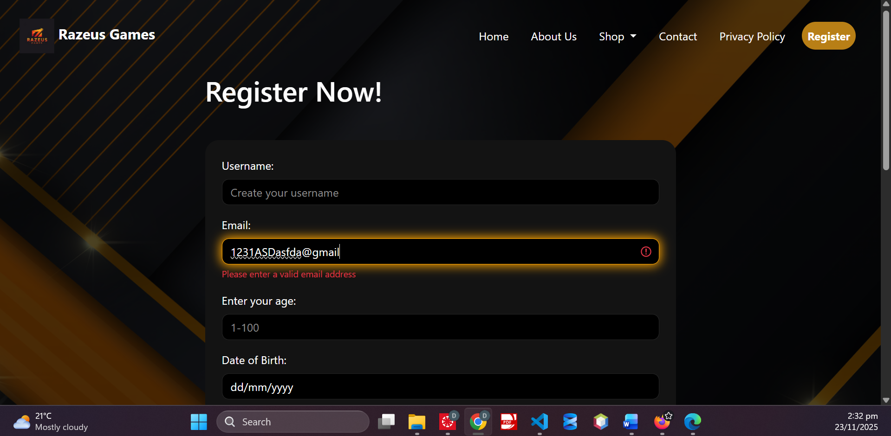

Screenshot ID 10:



Screenshot ID 11:

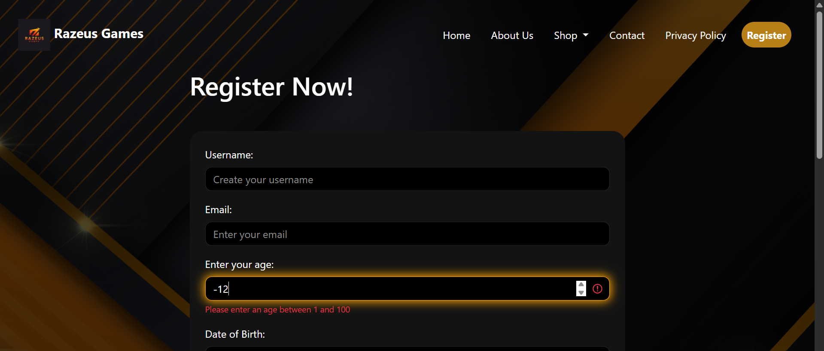 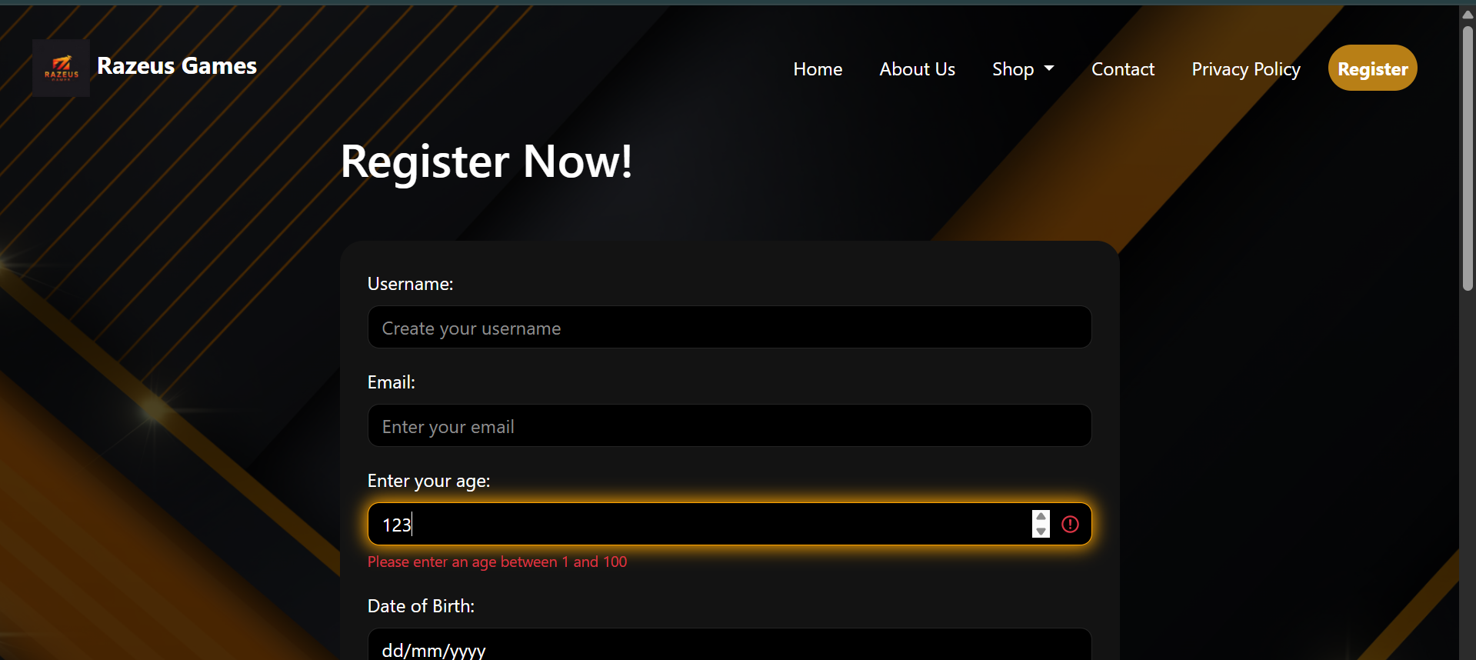

Screenshot ID 12:



Screenshot ID 13:

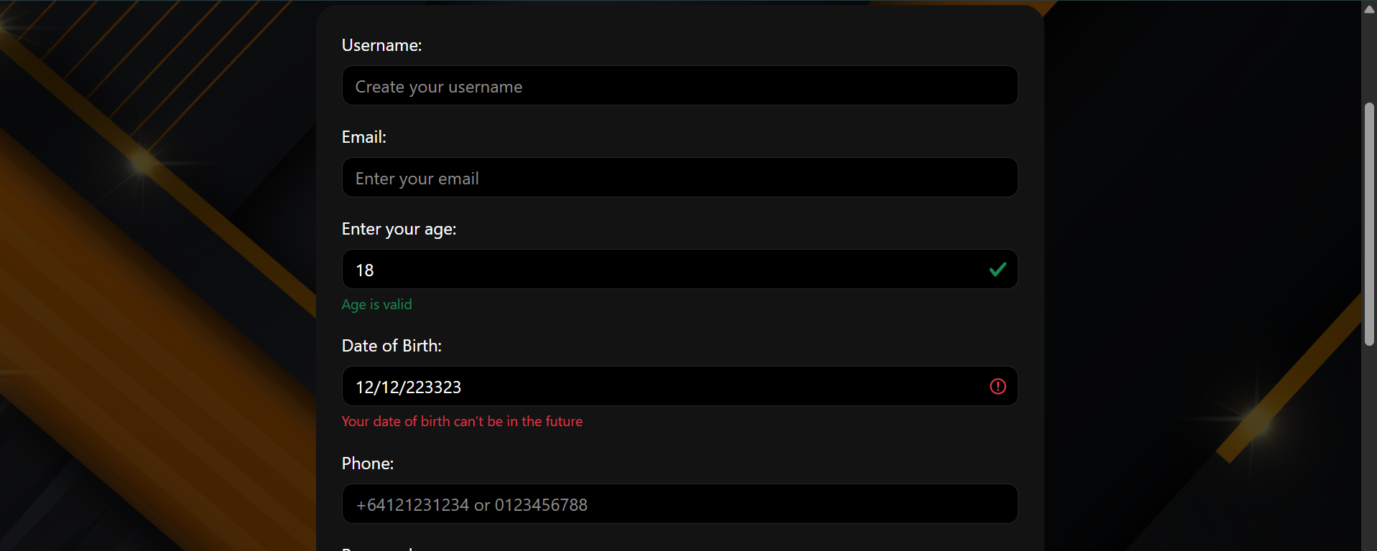

Screenshot ID 14:

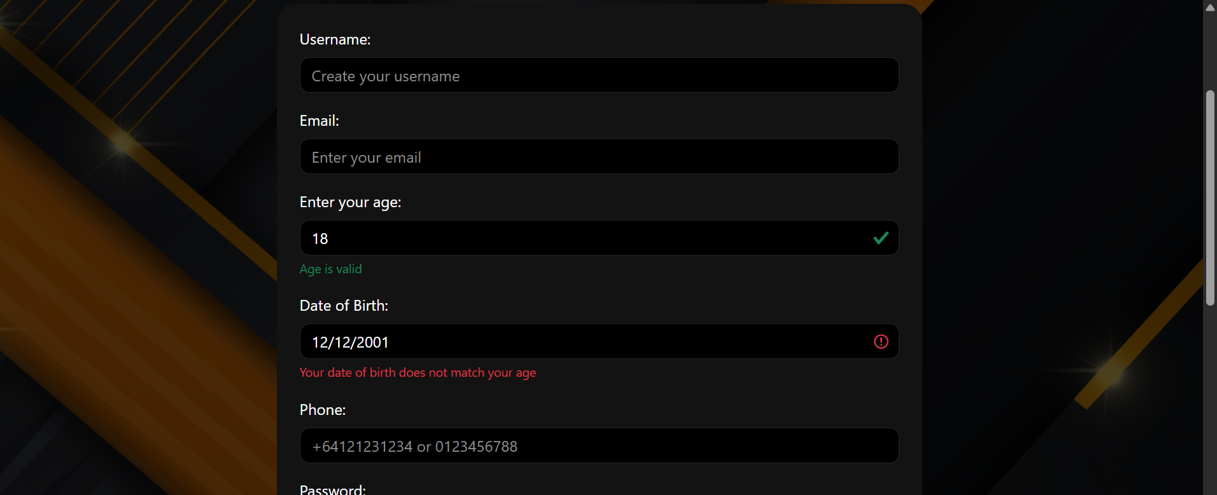

Screenshot ID 15:

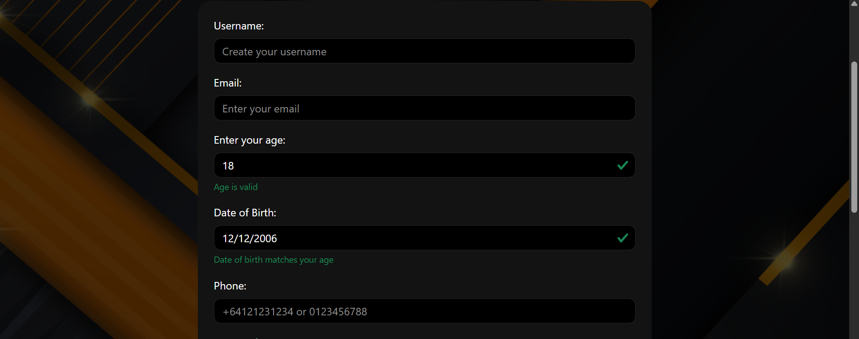

Screenshot ID 16:

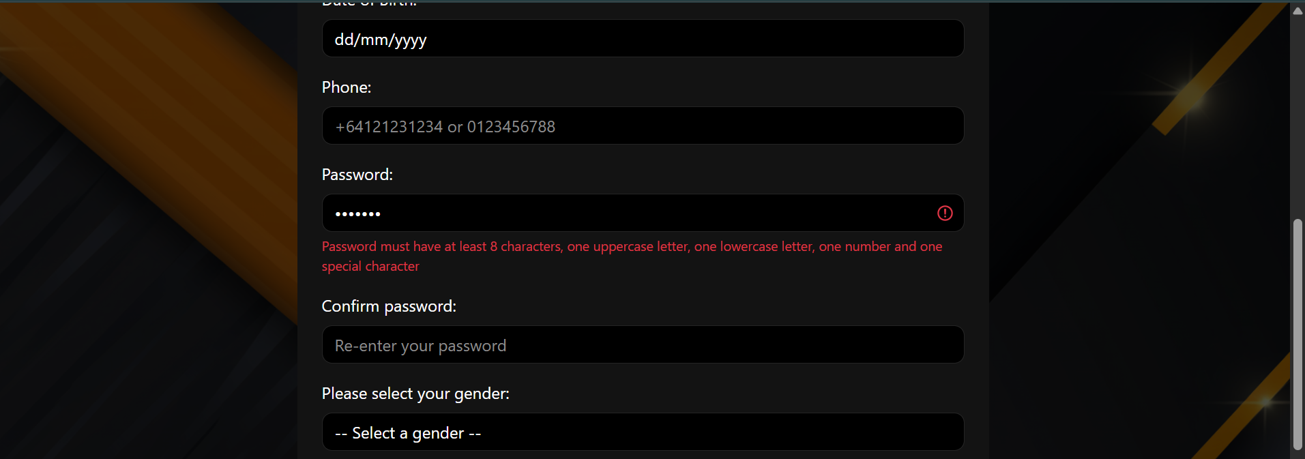

Screenshot ID 17:

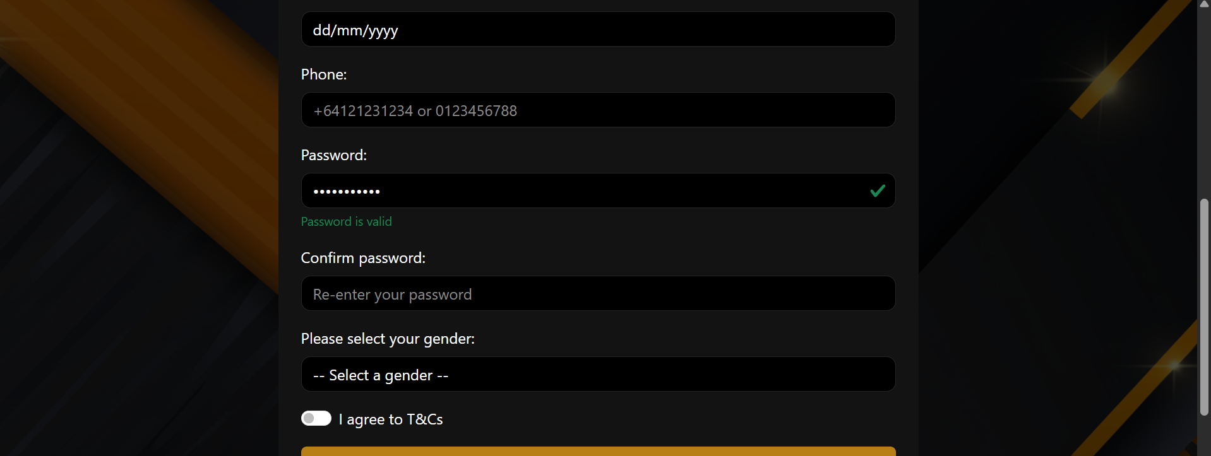

Screenshot ID 18:

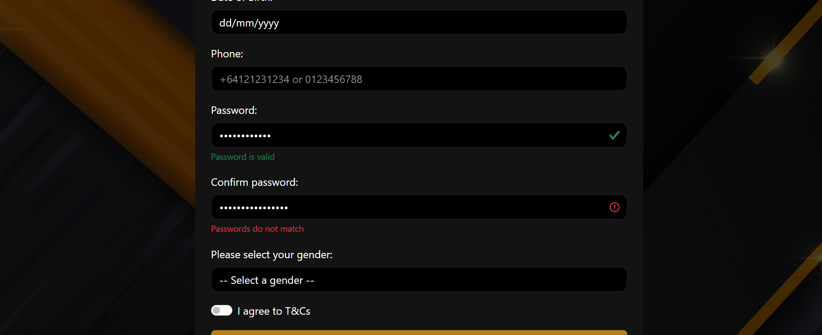

Screenshot ID 19:

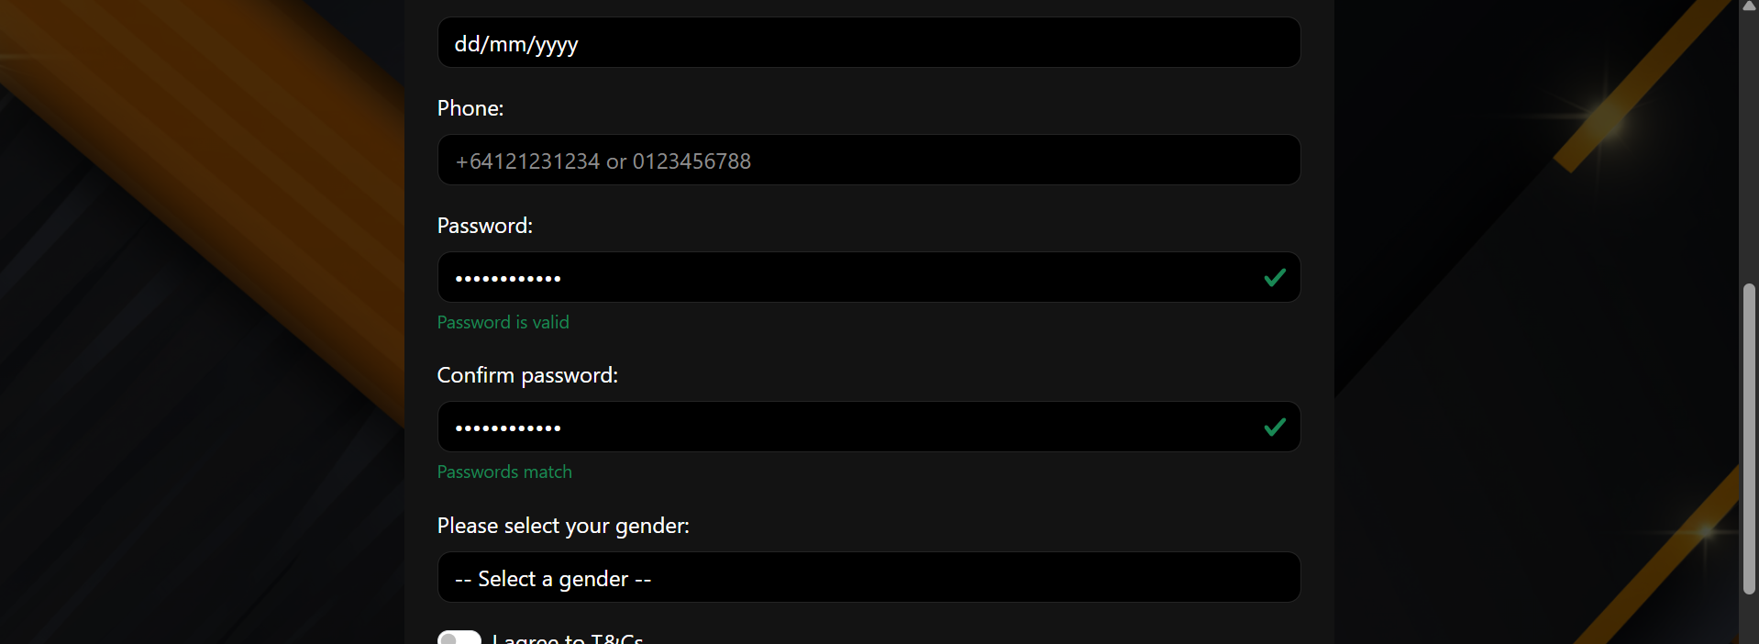

Screenshot ID 20:

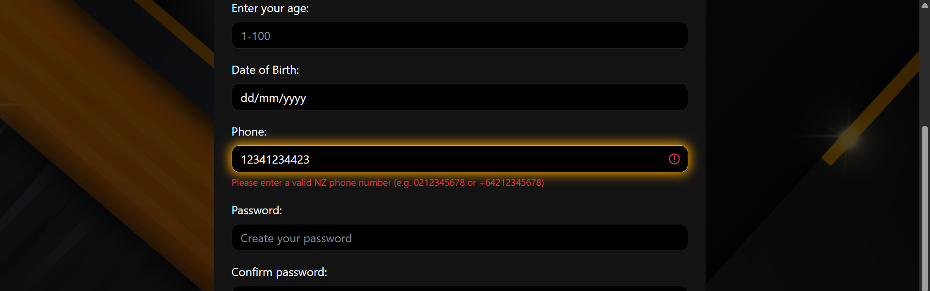

Screenshot ID 21:

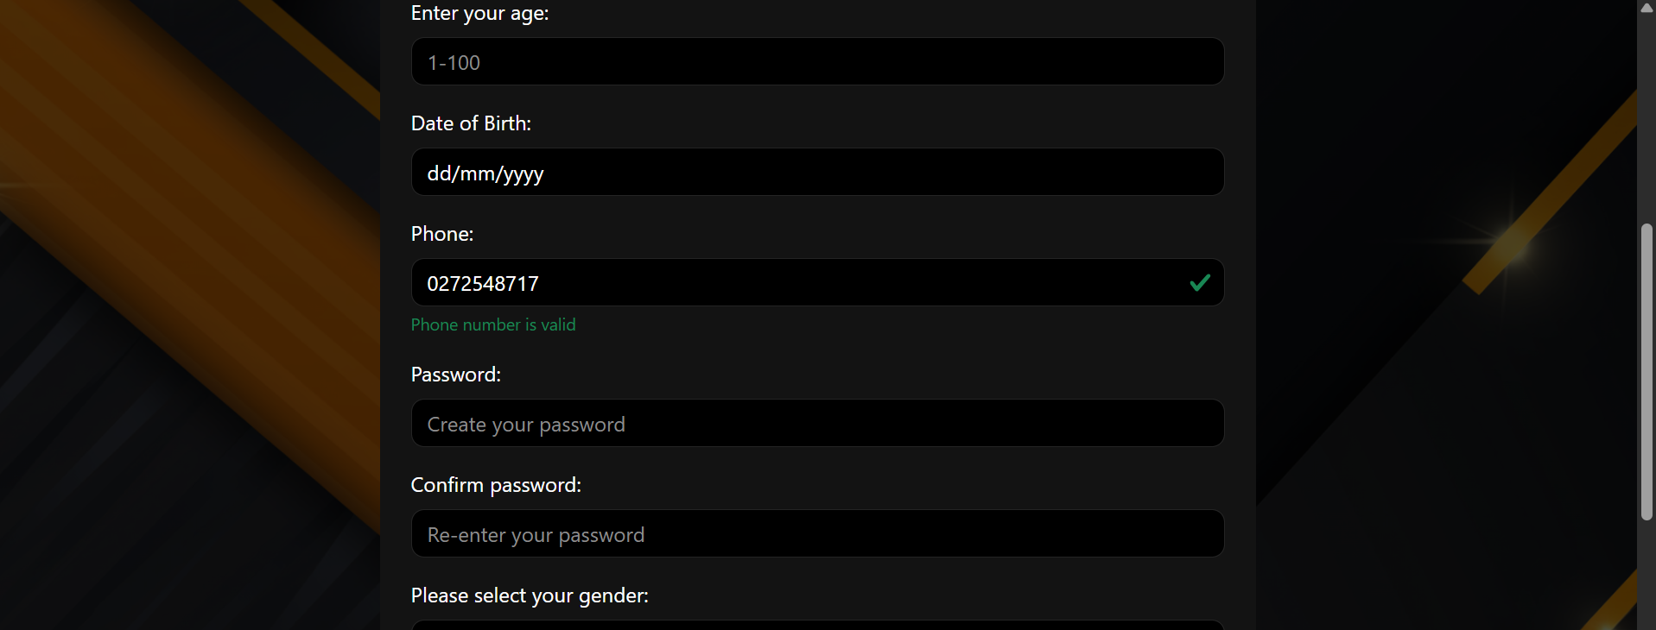

Screenshot ID 22:

  

Screenshot ID 23:

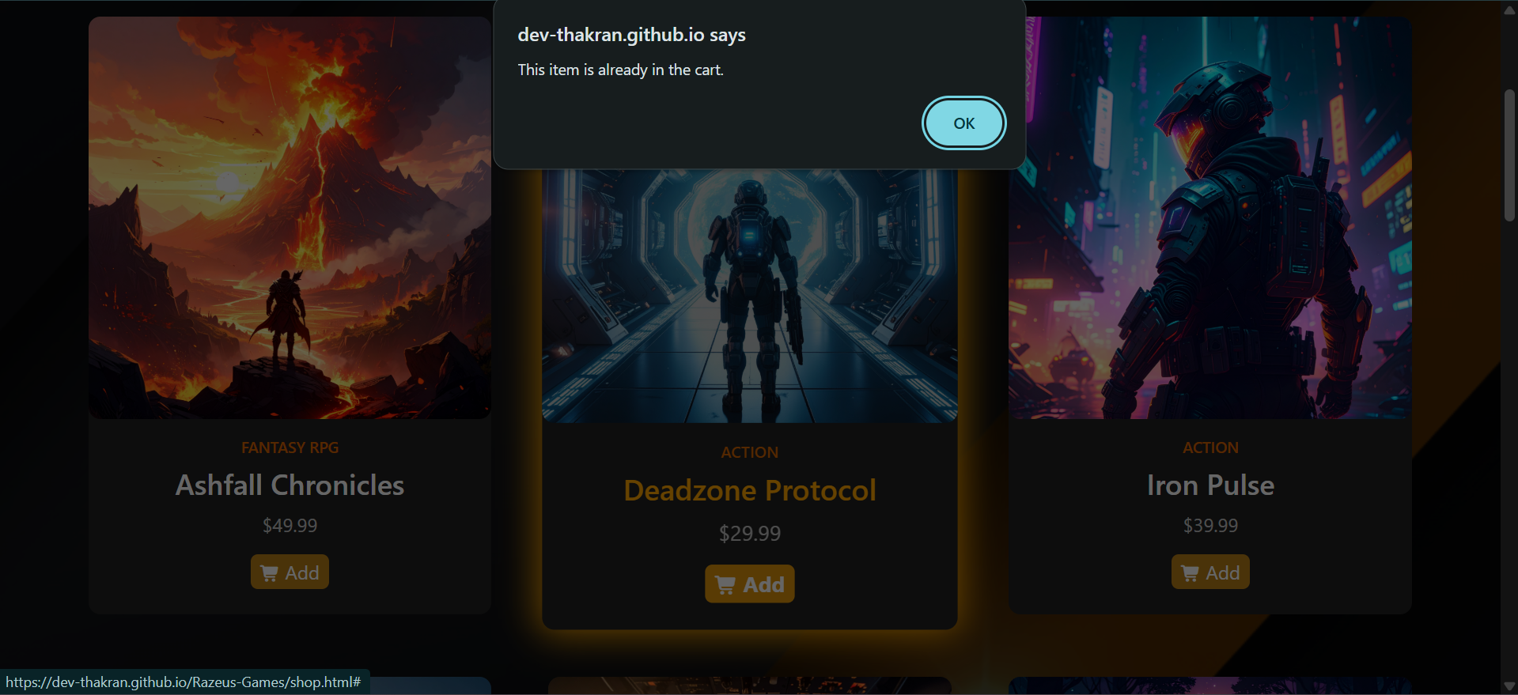

Screenshot ID 24:

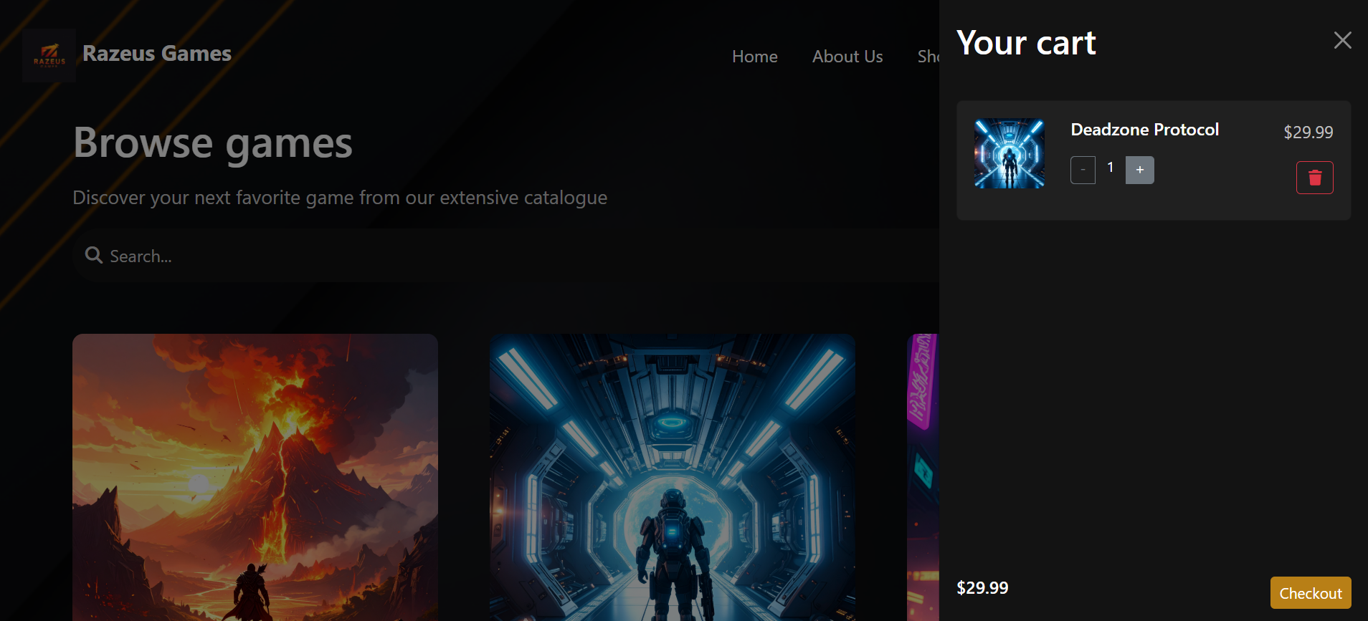 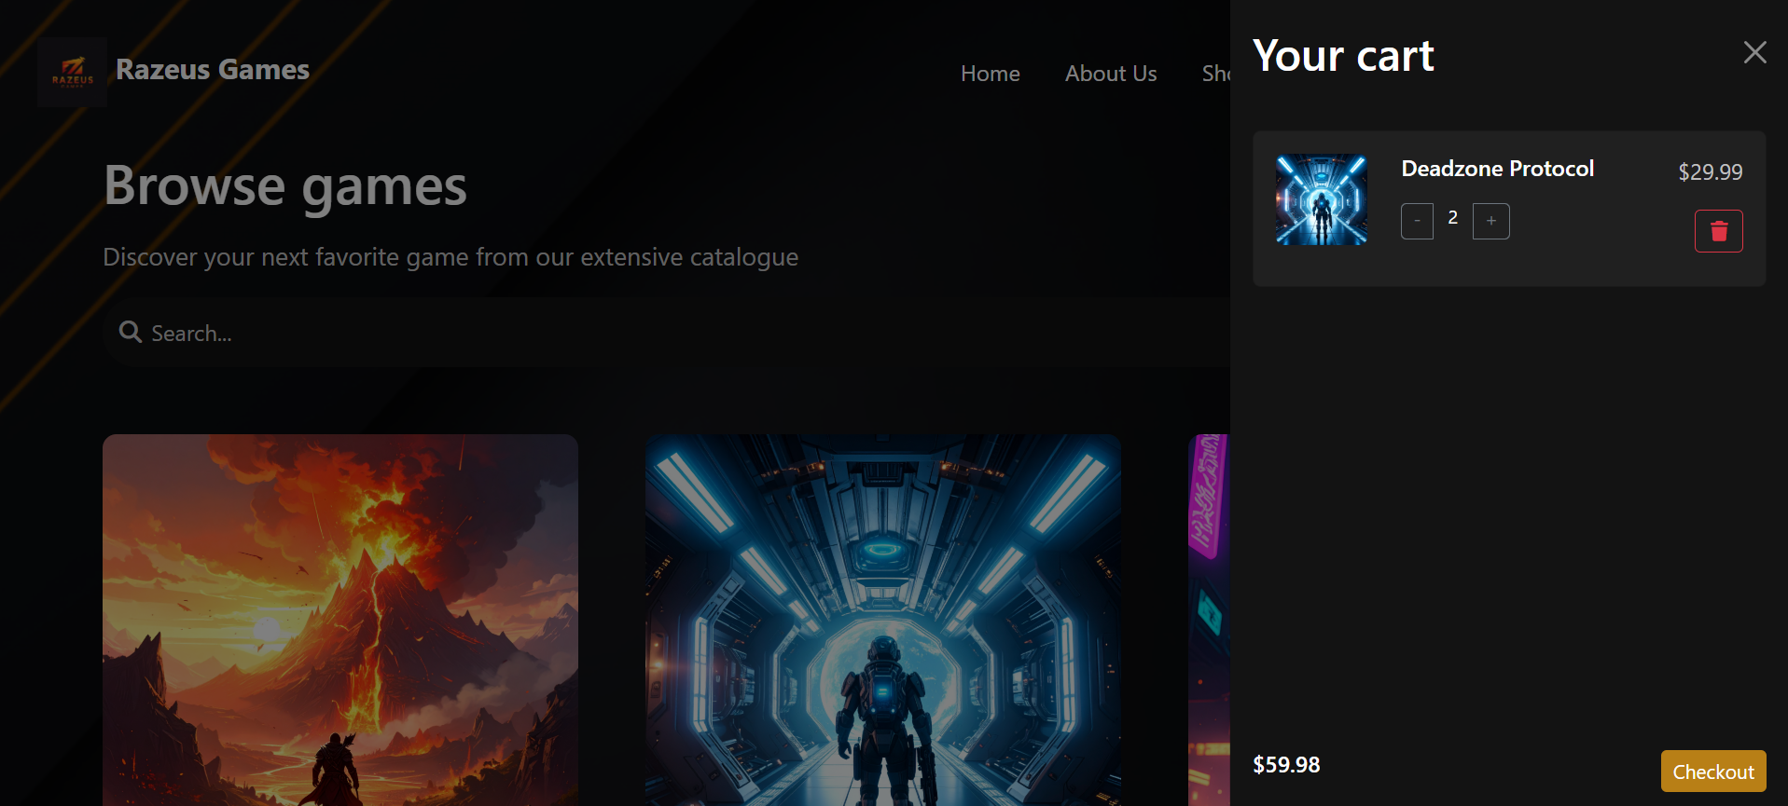  

Screenshot ID 25:





Screenshot ID 26:



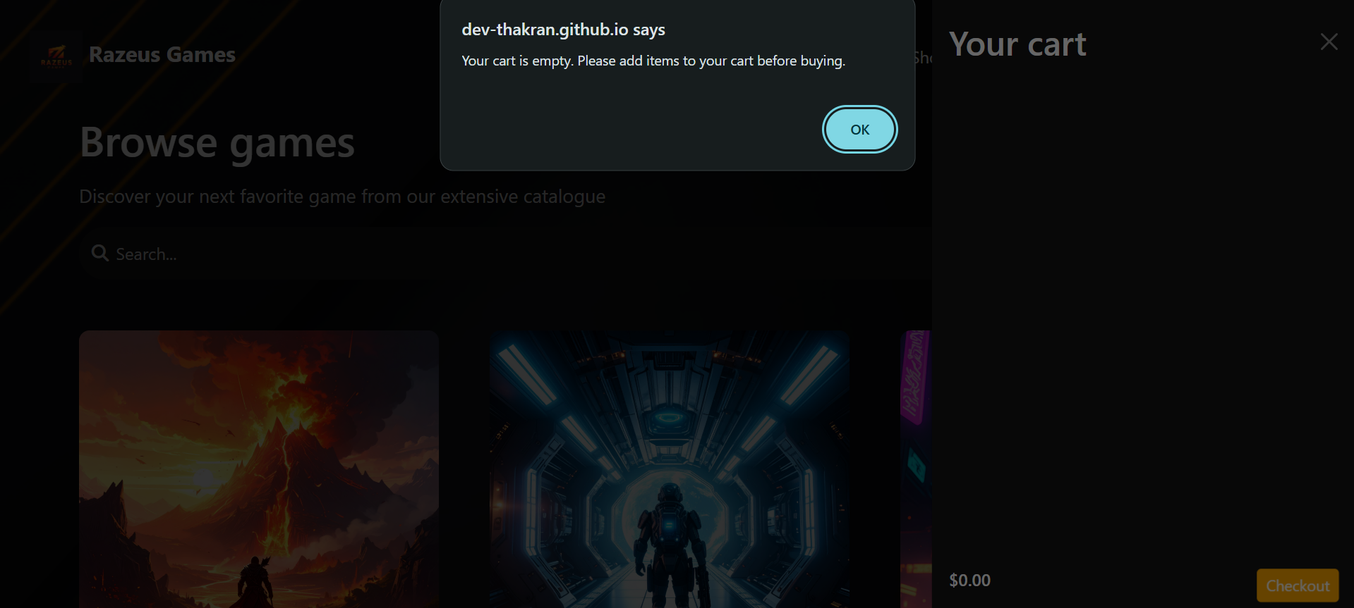

Screenshot ID 27:

 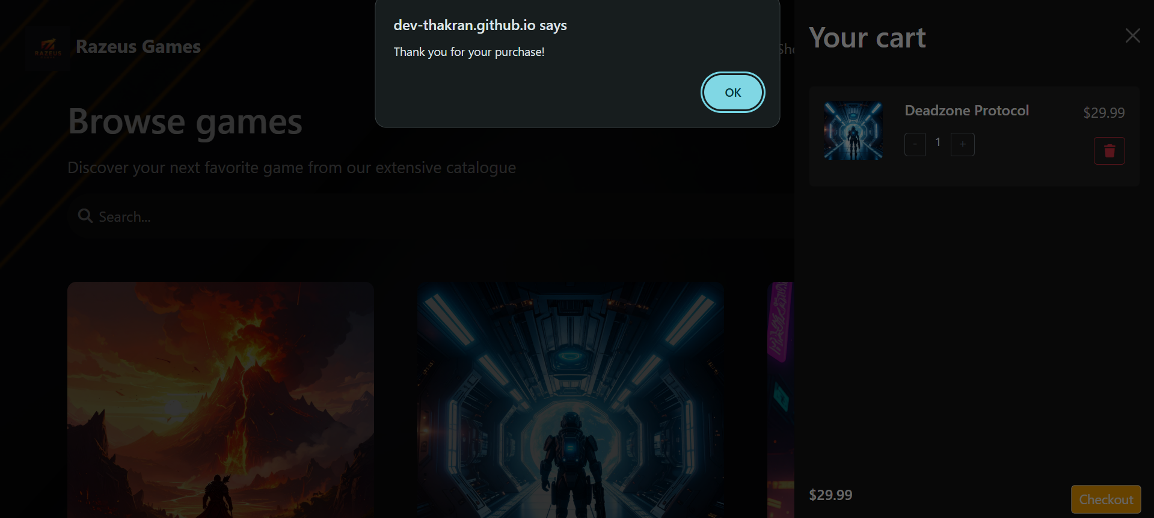 

Screenshot ID 28:

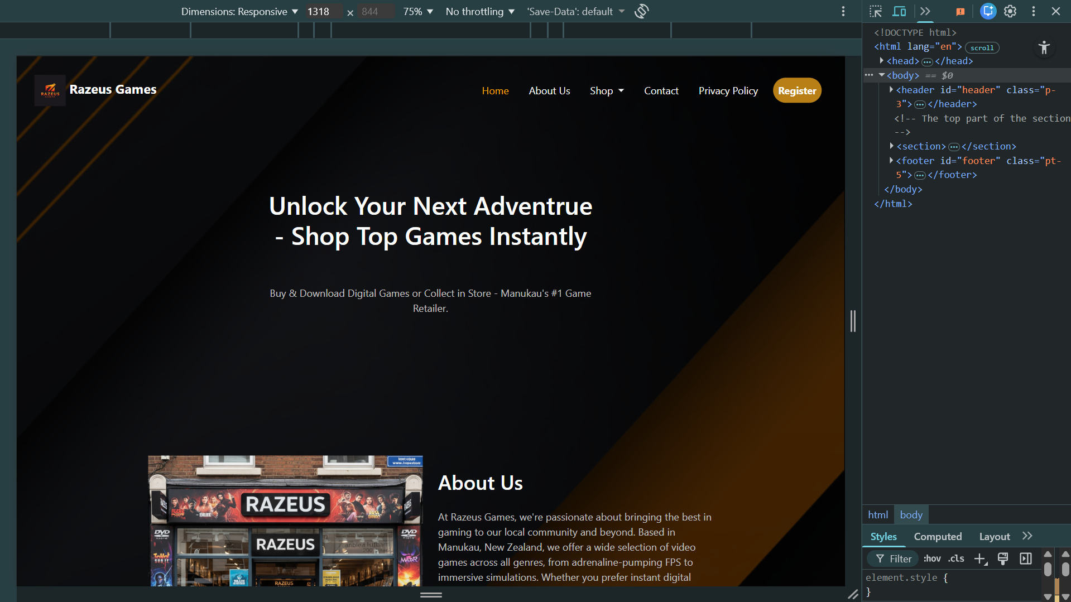 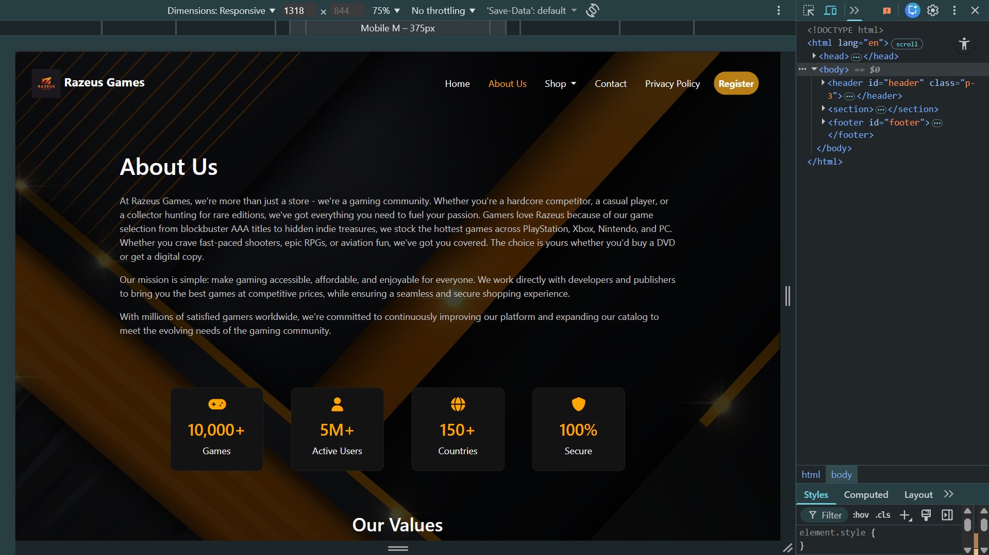 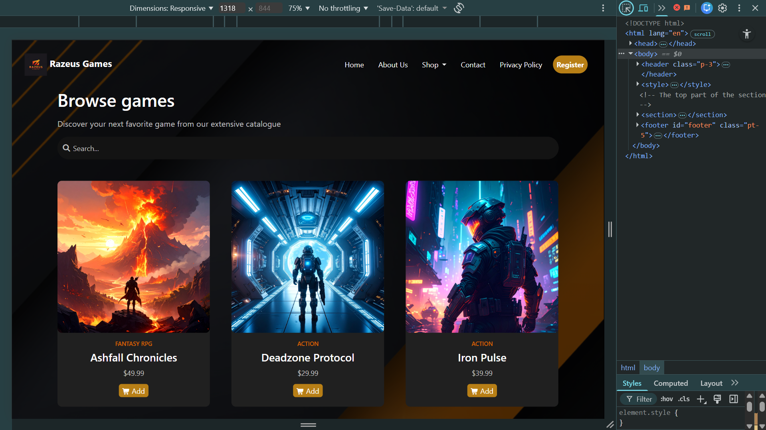

Screenshot ID 29:

 



Screenshot ID 30:



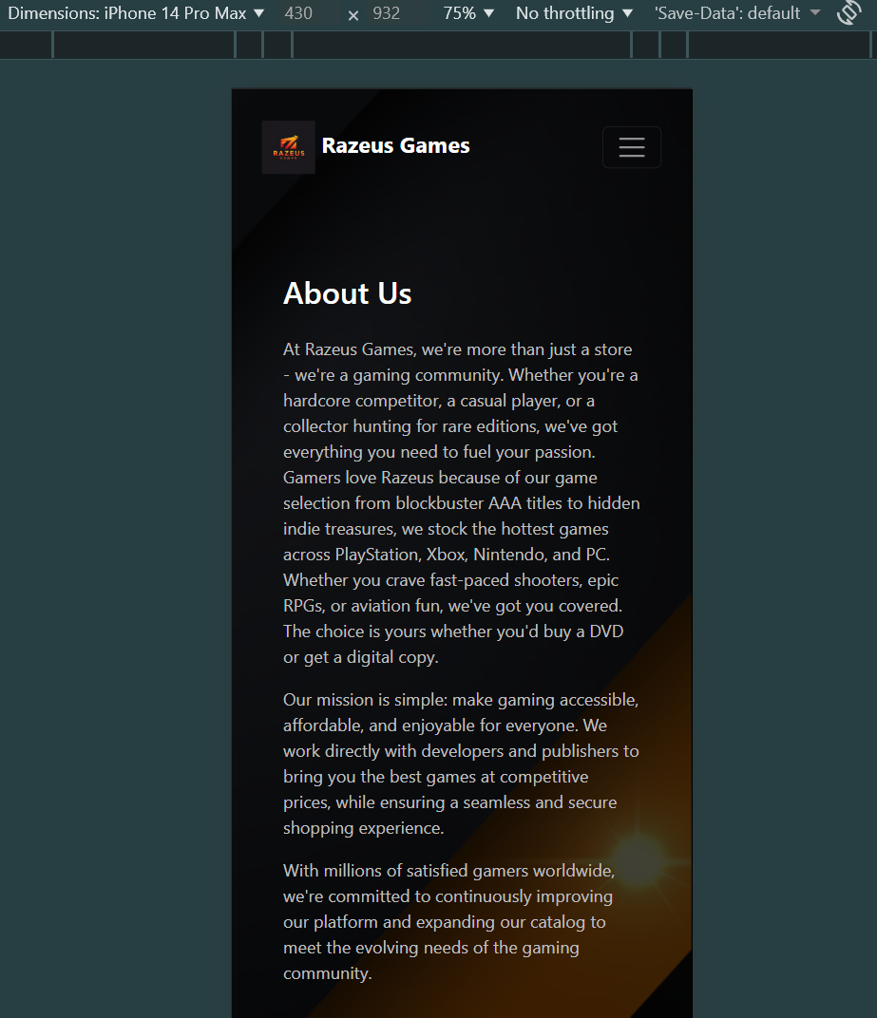 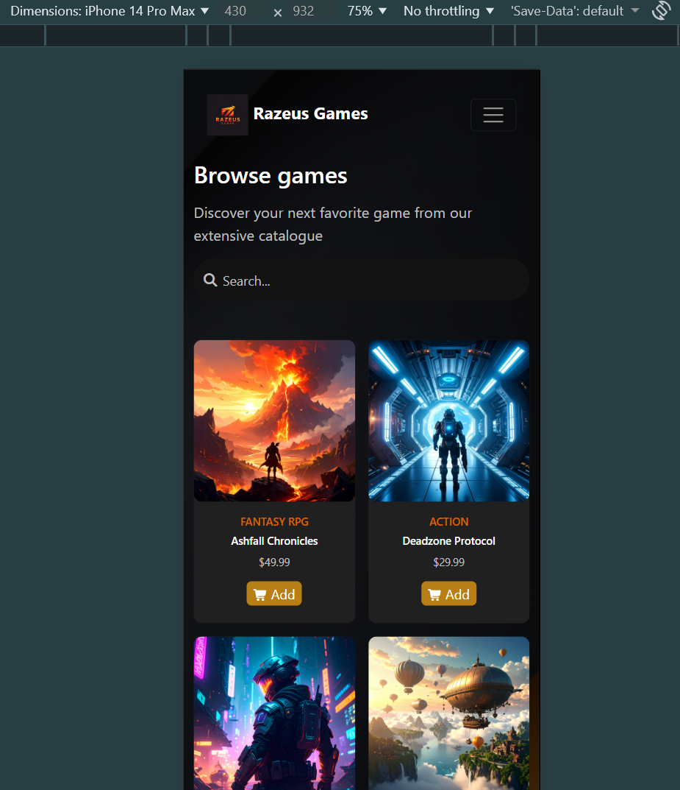

Screenshot ID 31: All the above screenshots are in chrome

Screenshot ID 32:

 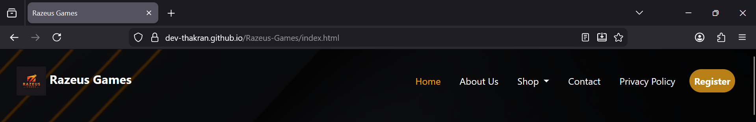 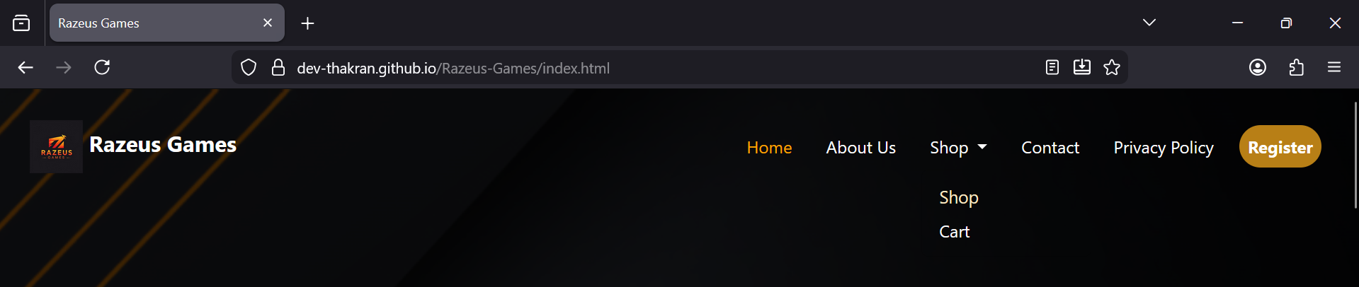 

 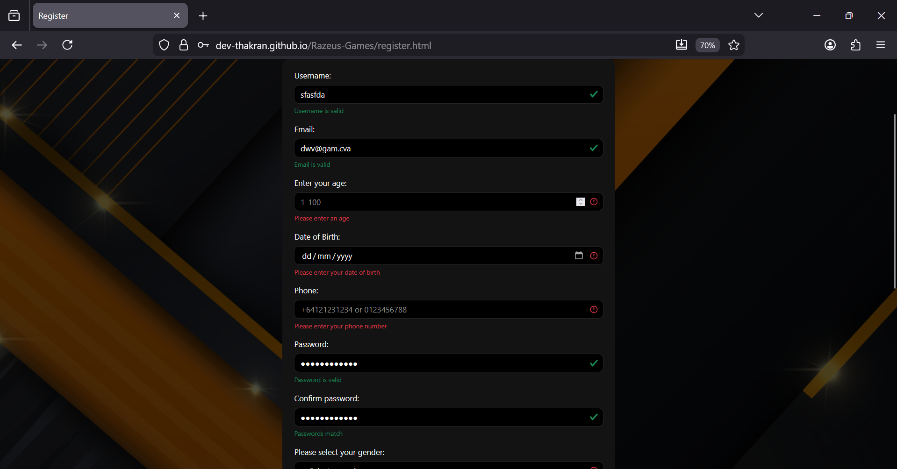 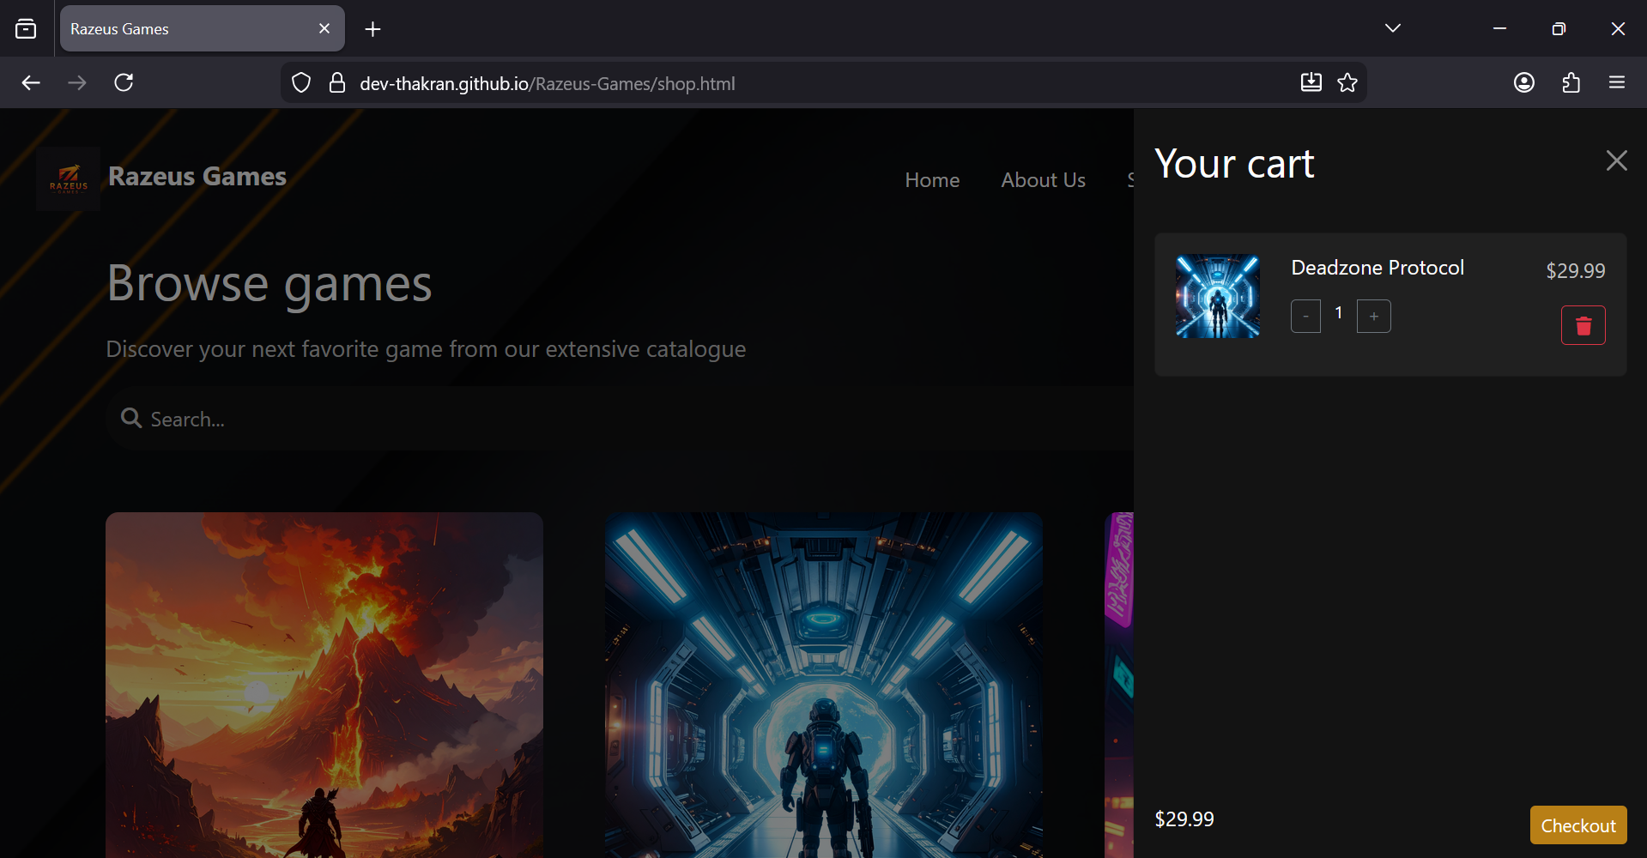

Screenshot ID 33:

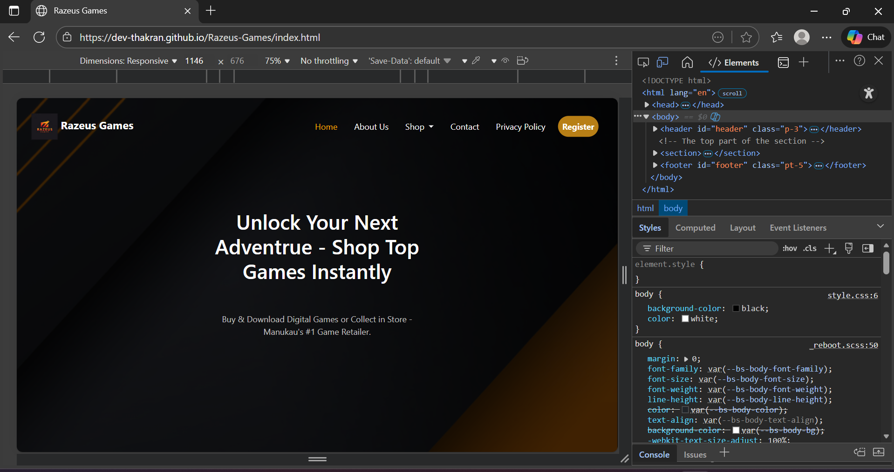 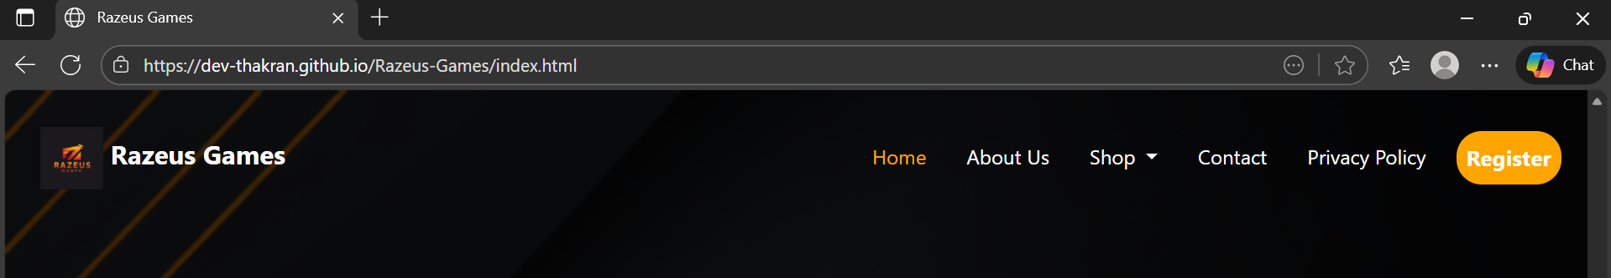  

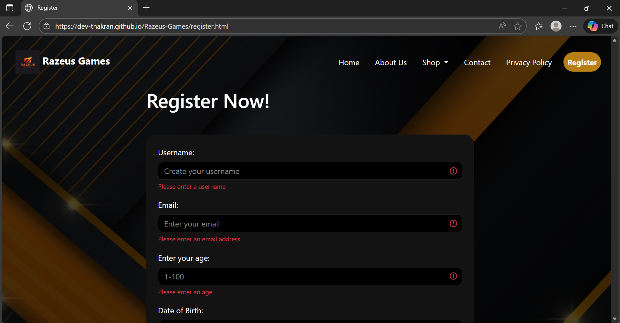 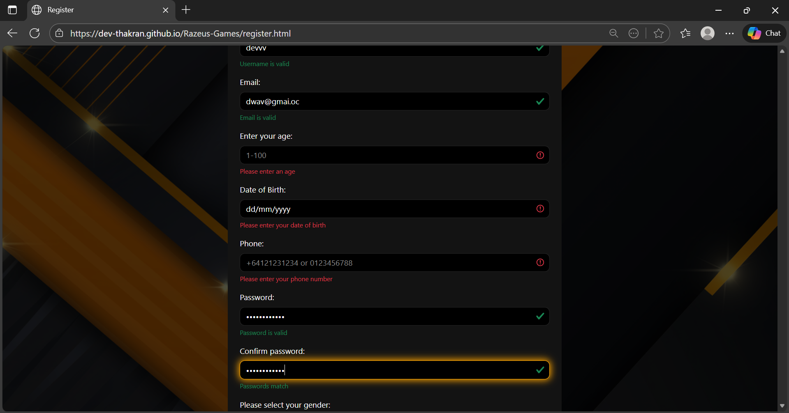 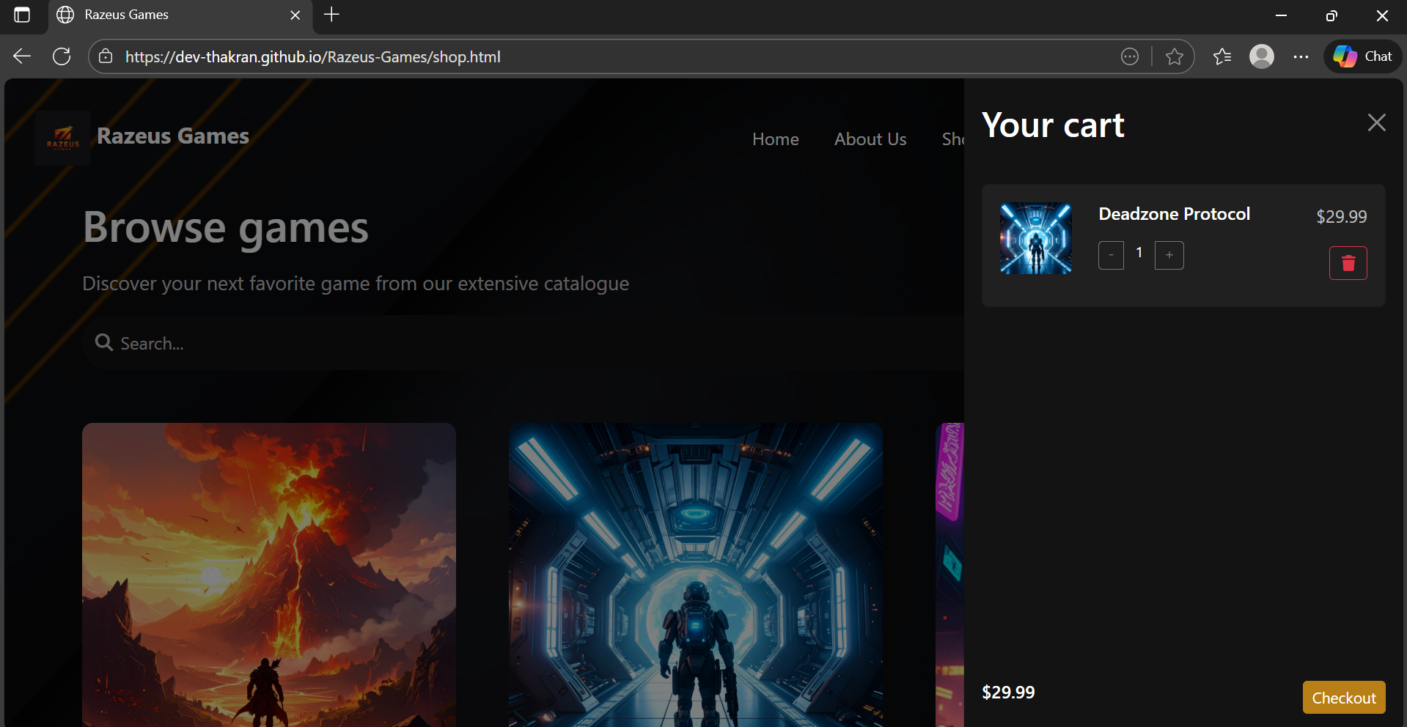

## Testing and Debugging

### Functional Testing

* All interactive features were tested to ensure correct operation:
* **Navigation**: Links redirect properly; dropdown menus display correctly; active page highlighting works.
* **Buttons**: Register, Add to Cart, Checkout buttons perform expected actions.
* **Forms**: Tested empty fields, invalid inputs, mismatched passwords, invalid age, incorrect phone number, and date-of-birth mismatch. Form prevented submission until all fields were valid. Successful submission redirected to form-submitted.html.
* **Cart System**: Adding, incrementing, decrementing, and removing items updated total price correctly. Alert displayed when attempting checkout with an empty cart.

### HTML Validation:

All HTML files of the Razeus Games website were validated using the W3C Markup Validation Service. The validator helped identify minor issues such as unclosed tags, missing attributes, and incorrectly nested elements. These issues were corrected to ensure the site’s markup is standards-compliant, which improves cross-browser compatibility, accessibility, and reduces the likelihood of rendering errors. Screenshots of the validation results have been included in the appendix as evidence of systematic testing and correction.

Index Page:

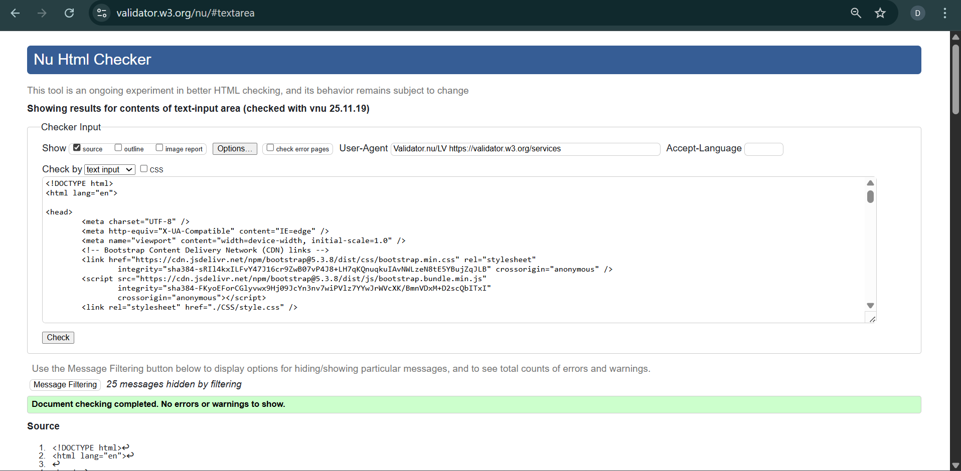

Shop Page: 2 errors

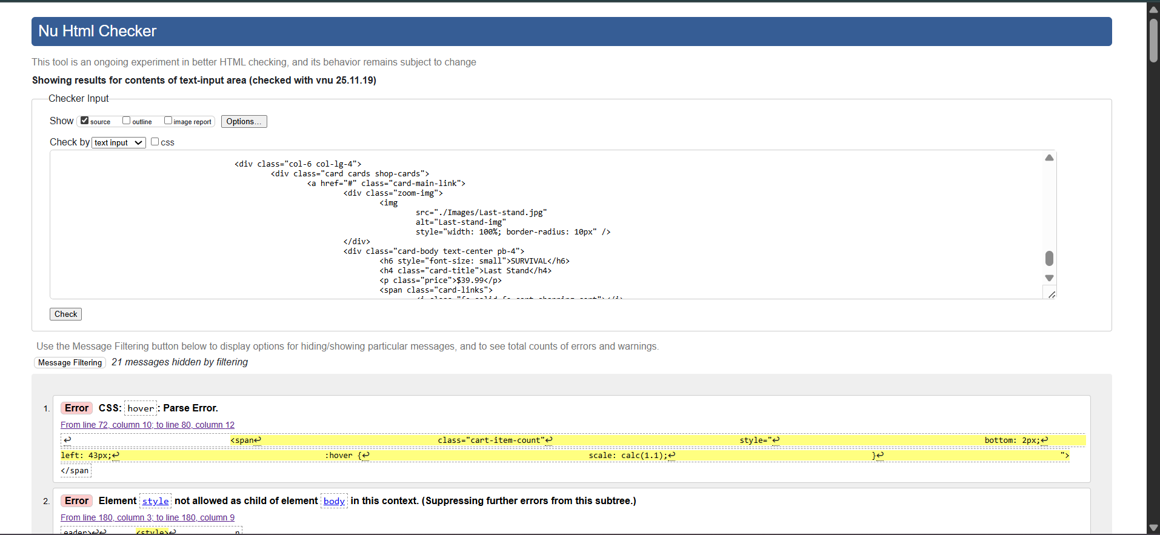

Fixed:

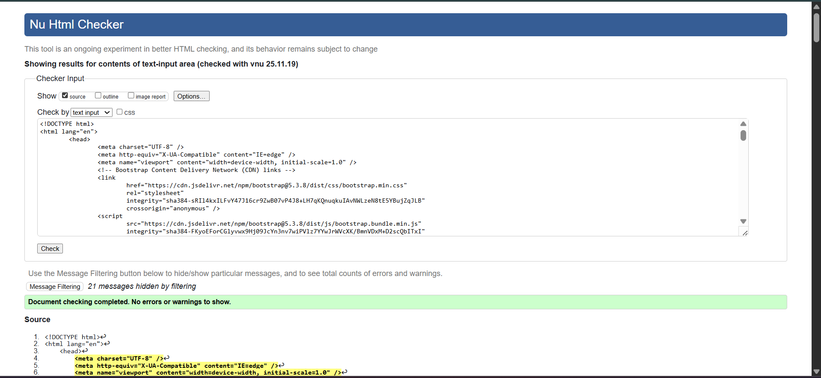

Register Page:

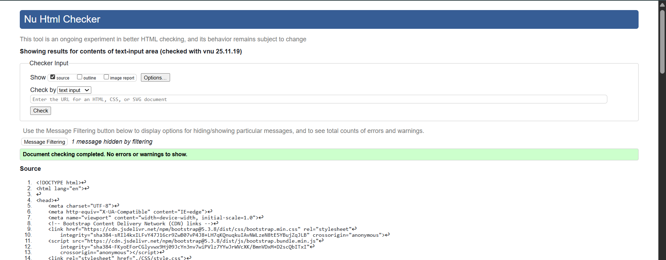

Privacy Policy page: 1 error

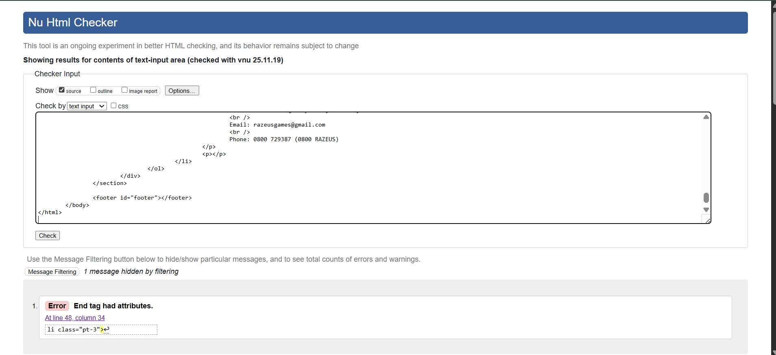

Fixed:

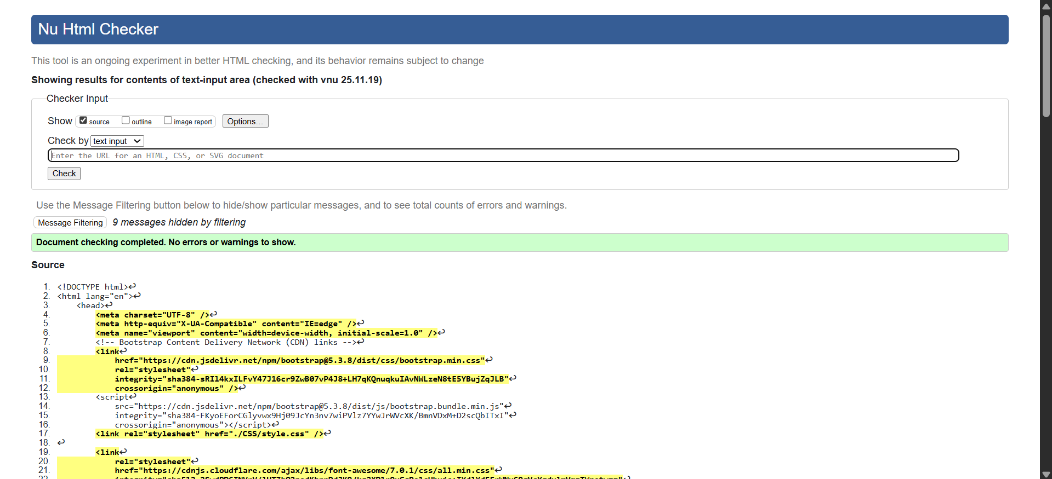

Header page: 4 errors

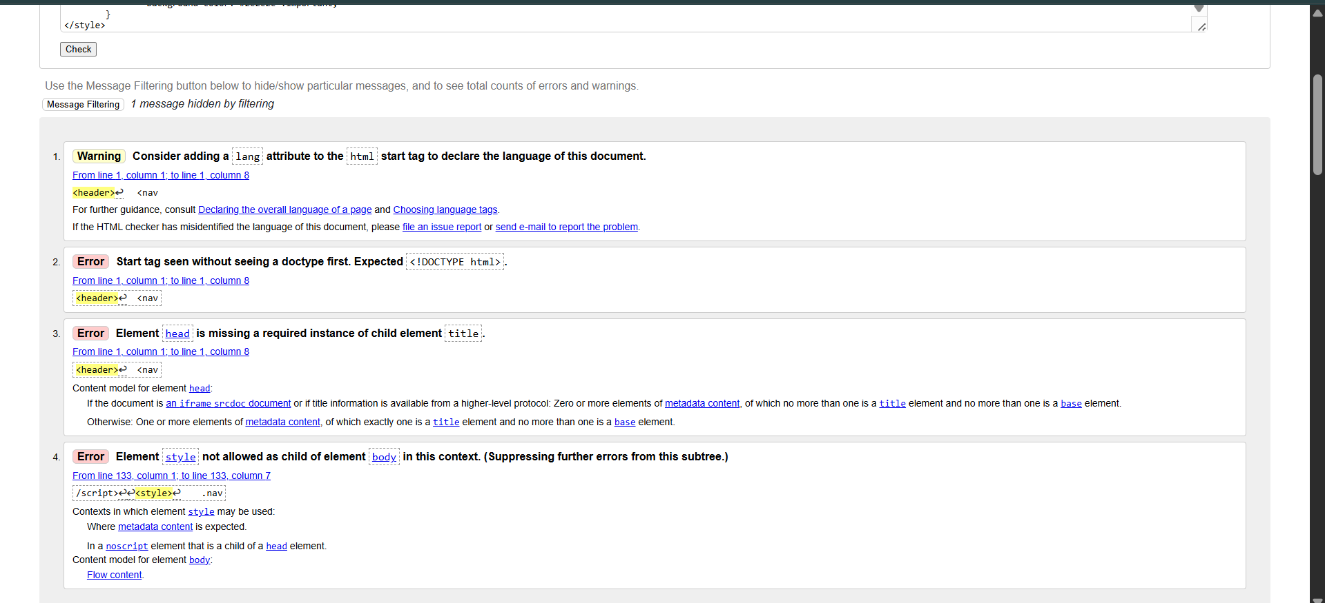Fixed:

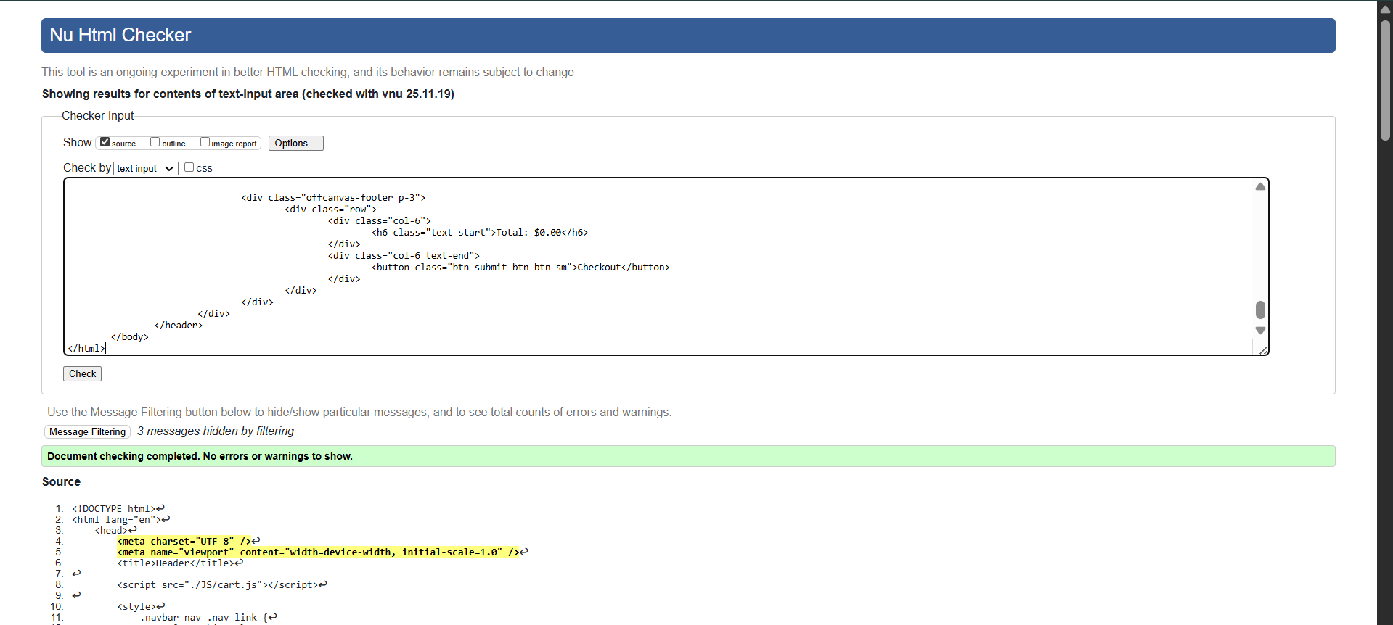Form-submitted page:

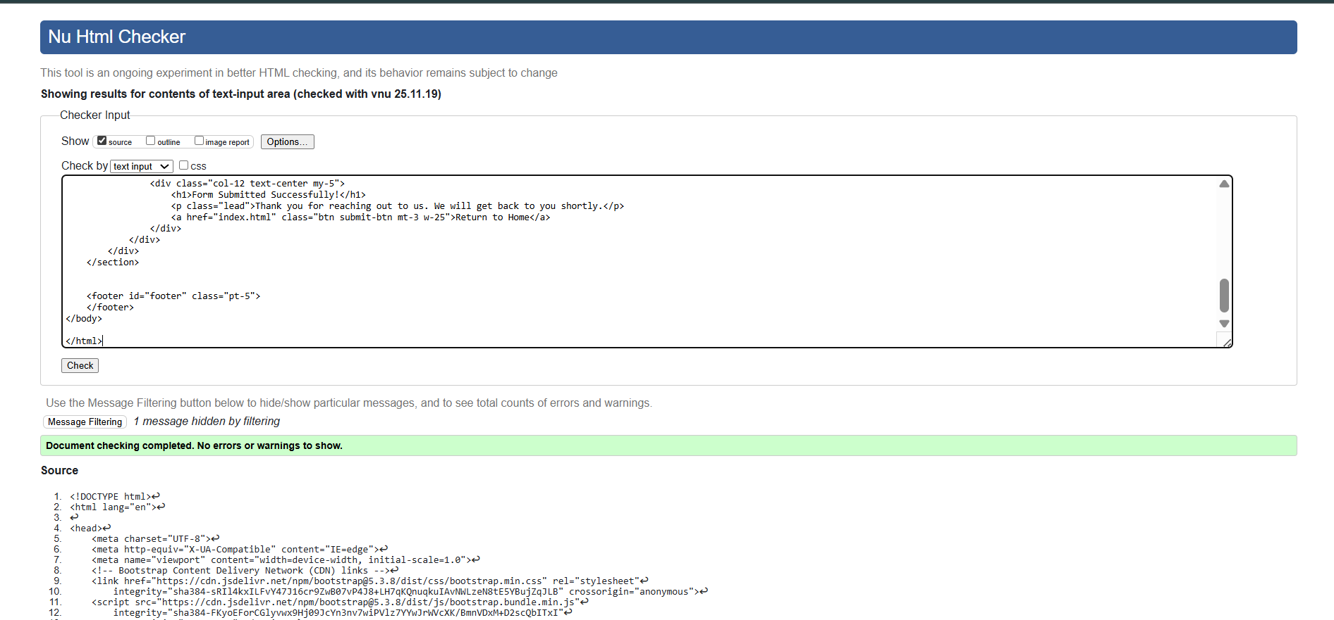

Footer page: Same as header 4 errors

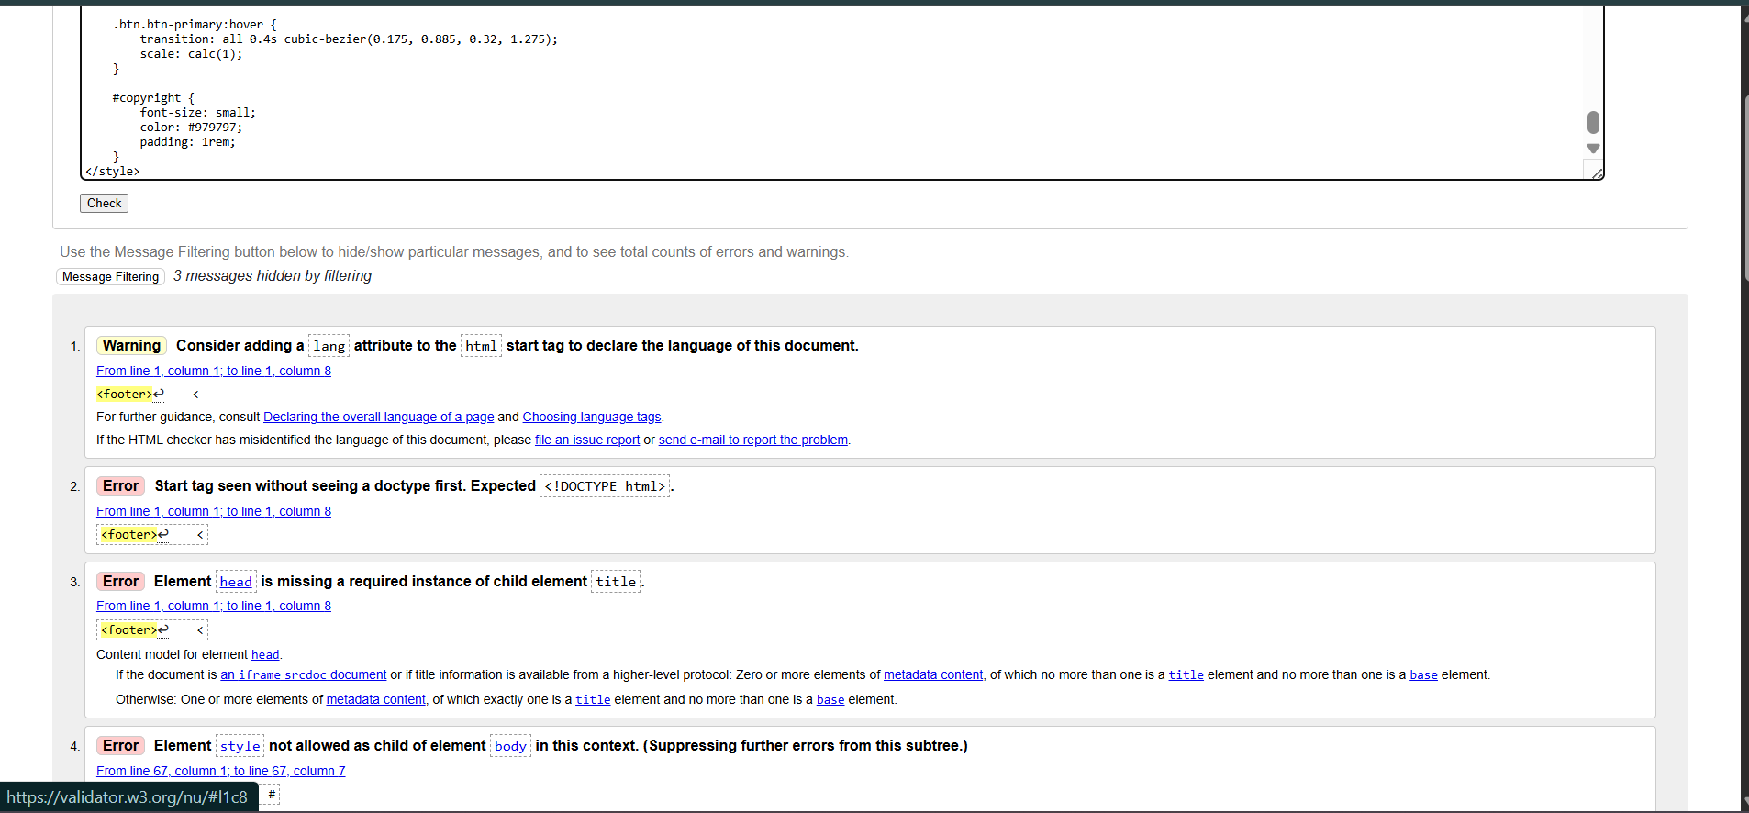Fixed:

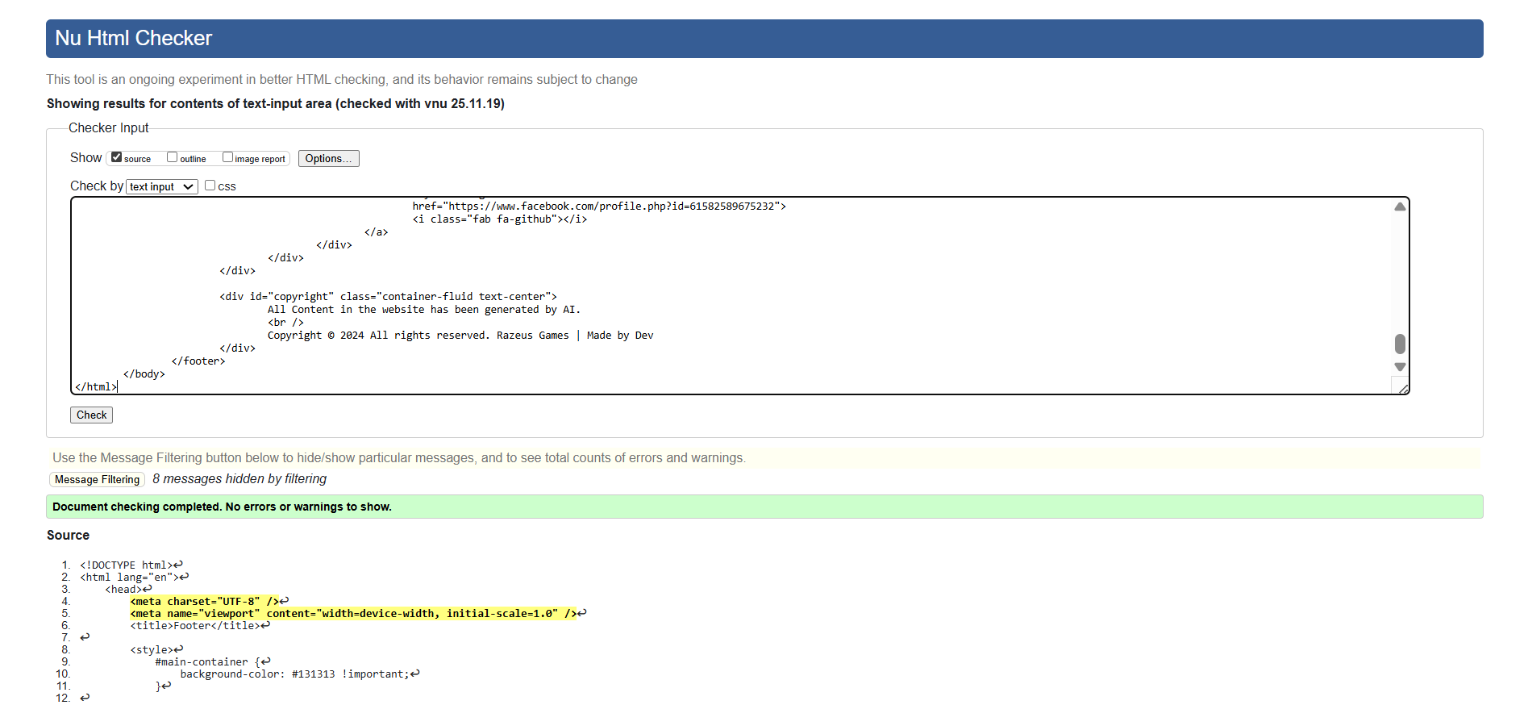Contact page:

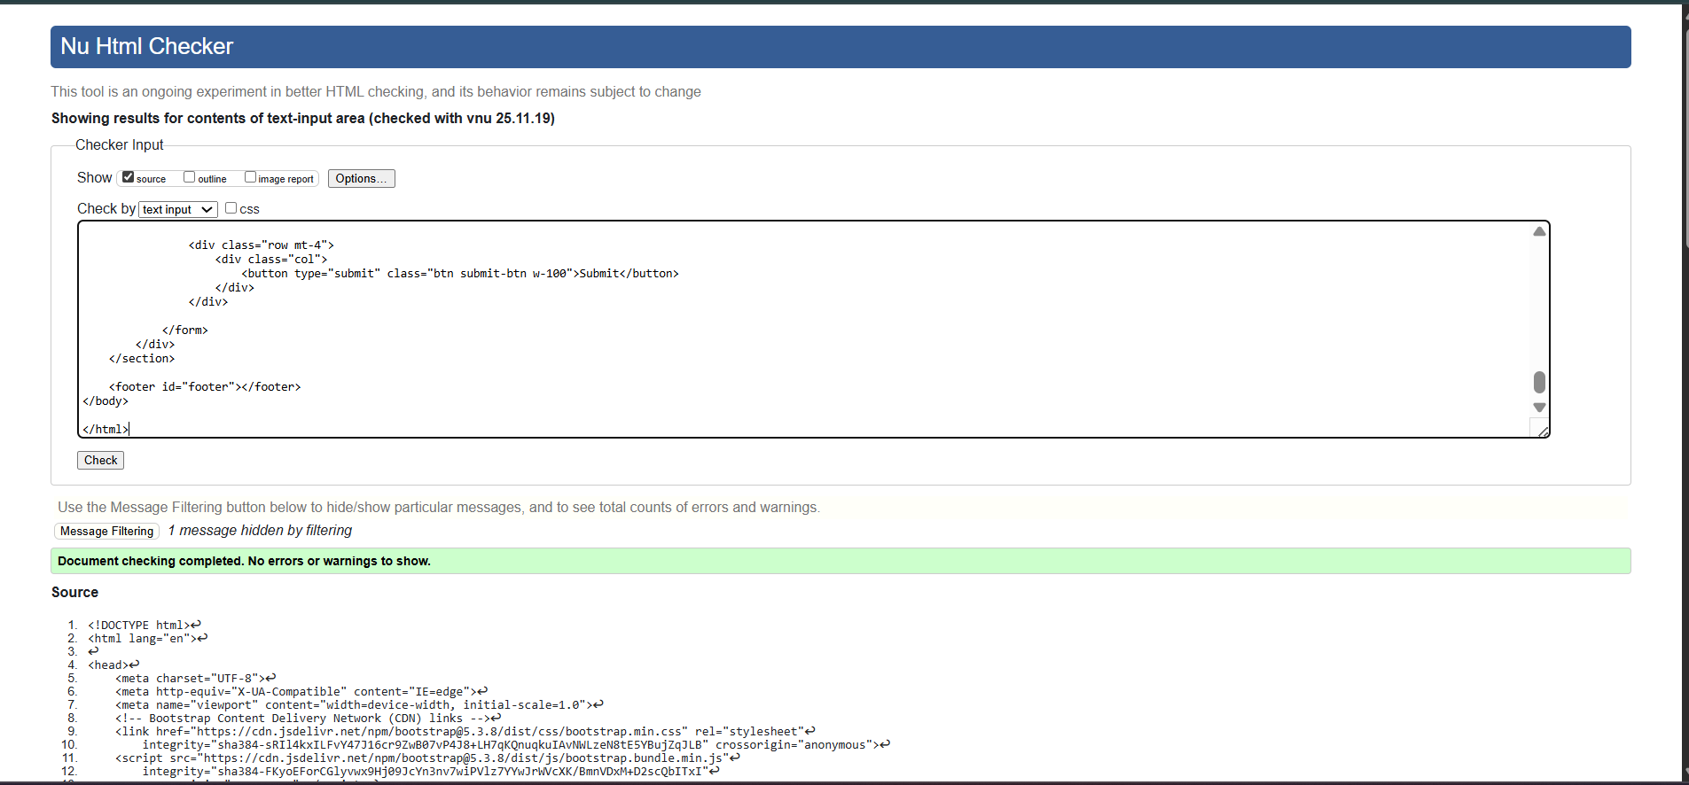

About us page:

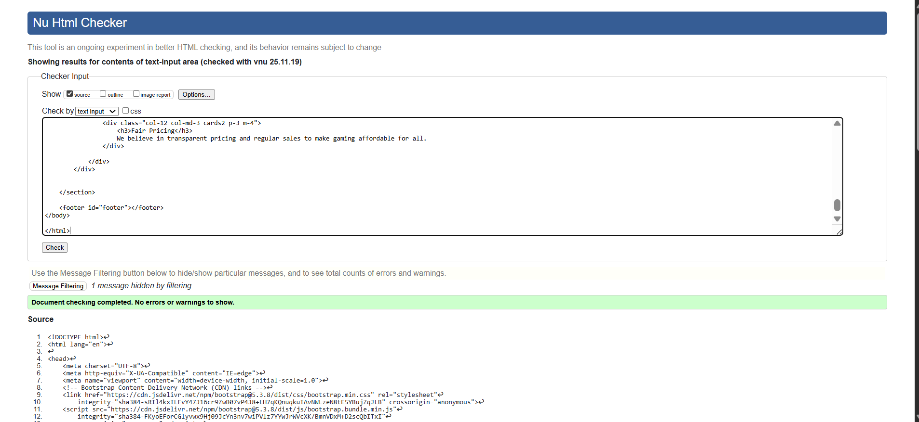

### Cross-Browser Testing

The website was tested on three browsers:

* Chrome – All features functional and visually correct.
* Firefox – Functional and layout consistent.
* Edge – Functional and layout consistent with other browsers.

Chrome:



Firefox:



Edge:

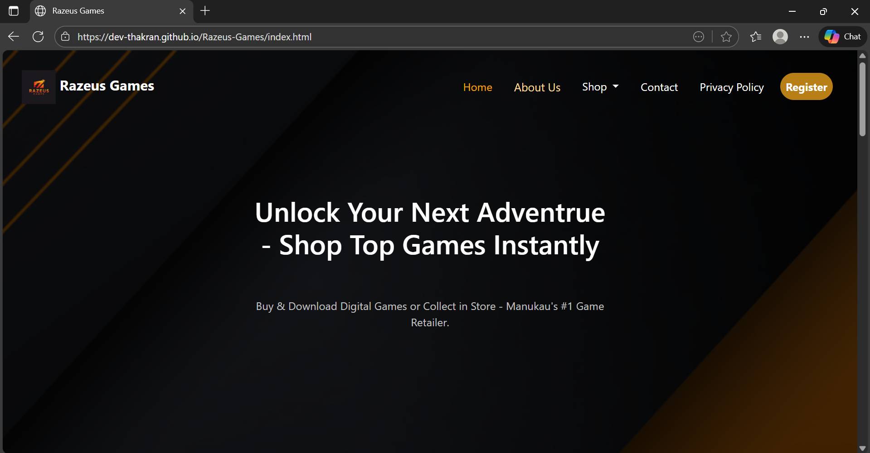

### Responsiveness Testing

Website tested using developer tools on multiple devices:

* Desktop: Full-width layout displays correctly.
* Tablet: Cards and sections resize correctly; no content overlaps.
* Mobile: Forms, navigation, and shop cards stack properly; font sizes readable; buttons functional.

Desktop View:

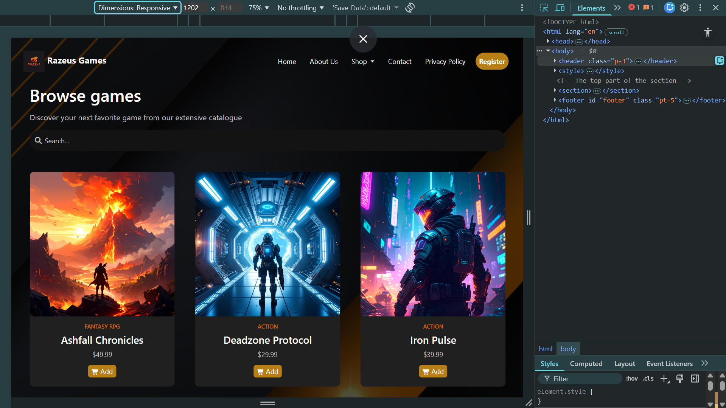

Tablet View:

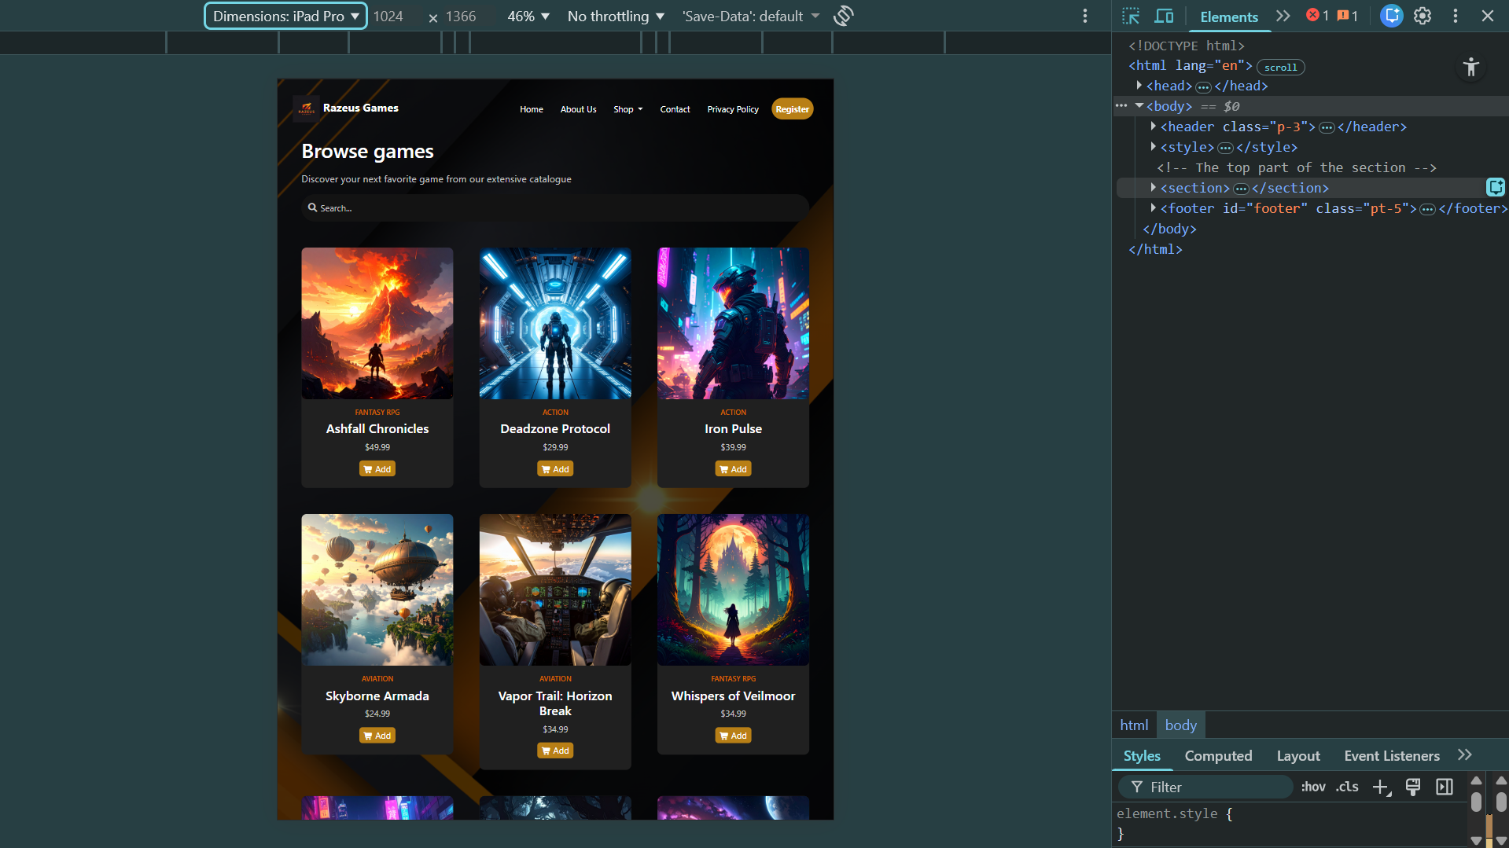

Phone View:

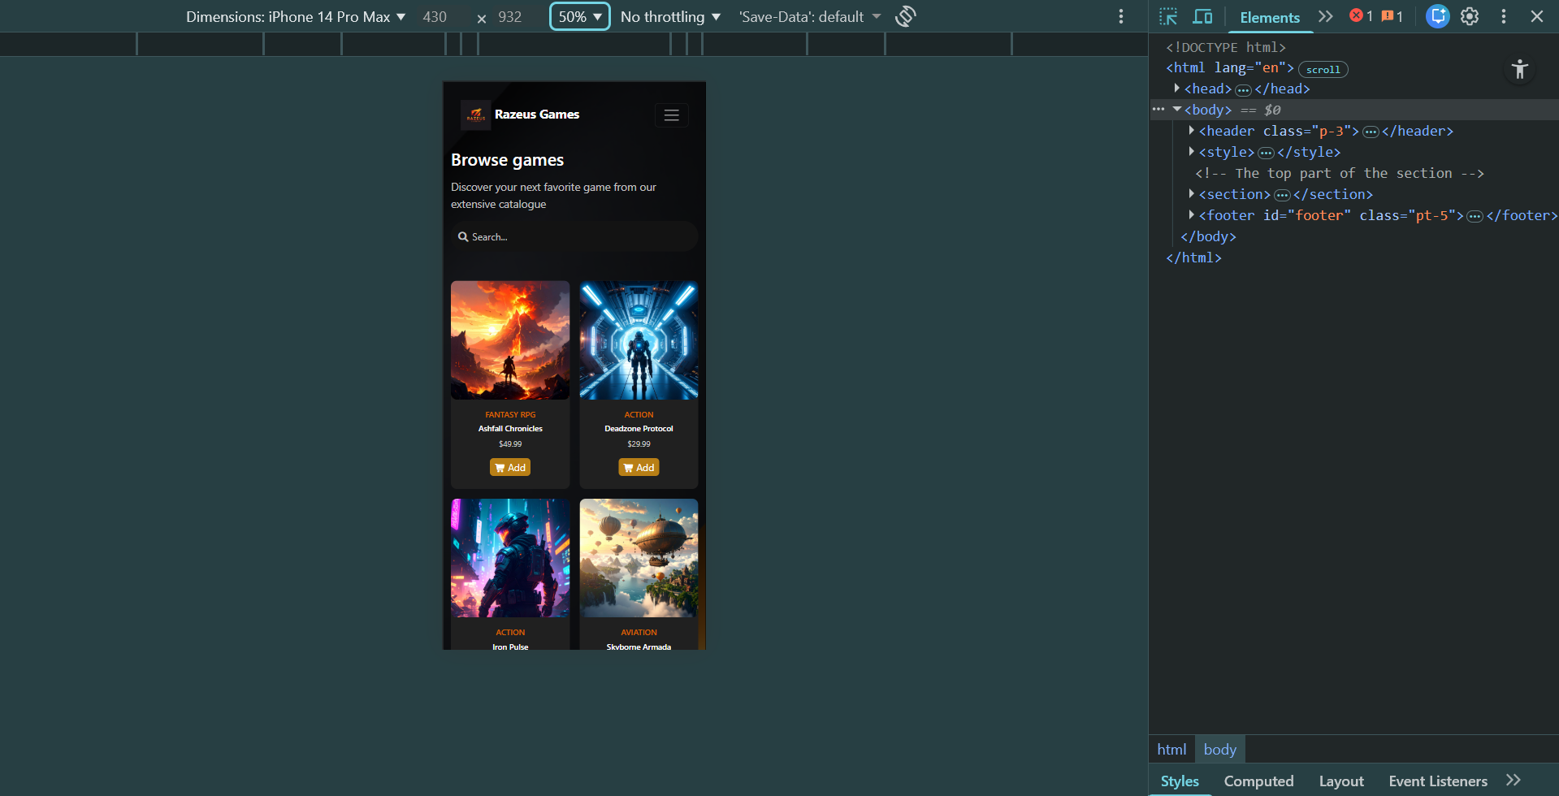

## 4. Bug Identification & Correction

### Bug 1: Invalid Email Submission

During testing of the registration and contact forms, a major issue was identified where the form allowed users to submit data even when an invalid email address was entered. This occurred because the email validation regex was not being checked during the final form submission process. Upon diagnosing the issue, it was clear that the validateEmail() function existed but was never called inside the main submit handler, meaning the browser accepted the submission without verification. To correct this, the email validation function was integrated directly into the submit event listener, and the default submission was prevented whenever the email format did not meet the required pattern. Before the fix, the form submitted successfully even with an incorrect email, which could lead to incorrect or unusable user data. After applying the correction, an appropriate error message is now displayed, and the form no longer submits until a valid email is entered.

### Bug 2: Cart Quantity Button Errors

Another significant issue emerged during functional testing of the shopping cart. The decrement button allowed the item quantity to drop below one, and the increment button occasionally failed to update the total price correctly. Investigation showed that the event listeners on the quantity buttons did not contain proper boundary checks, and the total price calculation was not consistently triggered after each change. To resolve this, a minimum quantity limit was implemented so that users can no longer decrement the value below one, and the total-price recalculation logic was added to both increment and decrement button actions. Before this fix, users could set quantity to zero—which broke the pricing—and total cost values displayed were sometimes outdated. After correction, the quantity remains at a minimum of one, and the total price now updates accurately on every button click.